Accessing Saved Information

Run Folders
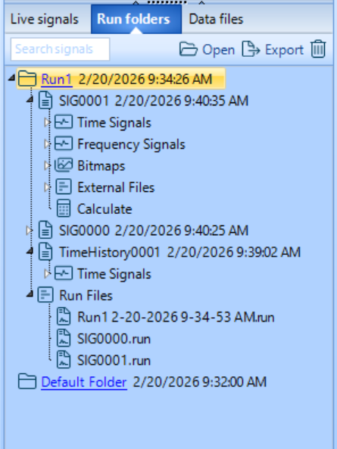
SIG Files contains information from Save functionality, includes block and frequency domain data
REC Files contains information from Recording functionality, includes time domain data. Record destination can be internal to the spider hardware or external to the PC
Time History Files contains profile RMS history, ramp up speed and run at level information is displayed here.

Change Saved Folder

Single Test
Setup →Test Configuration → File Directory
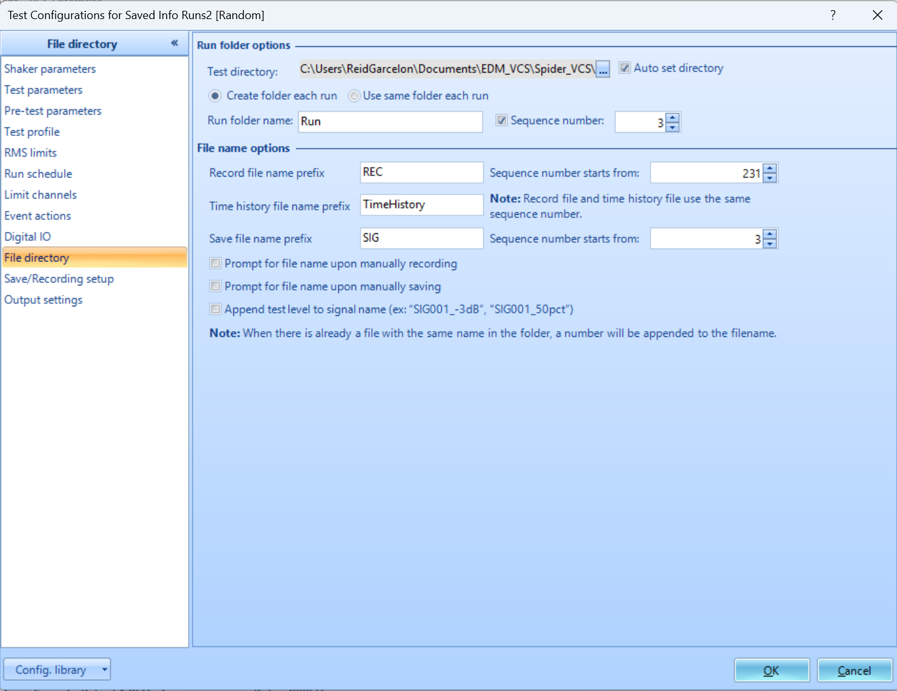

All Tests
Tools → Global Settings → Working Folder
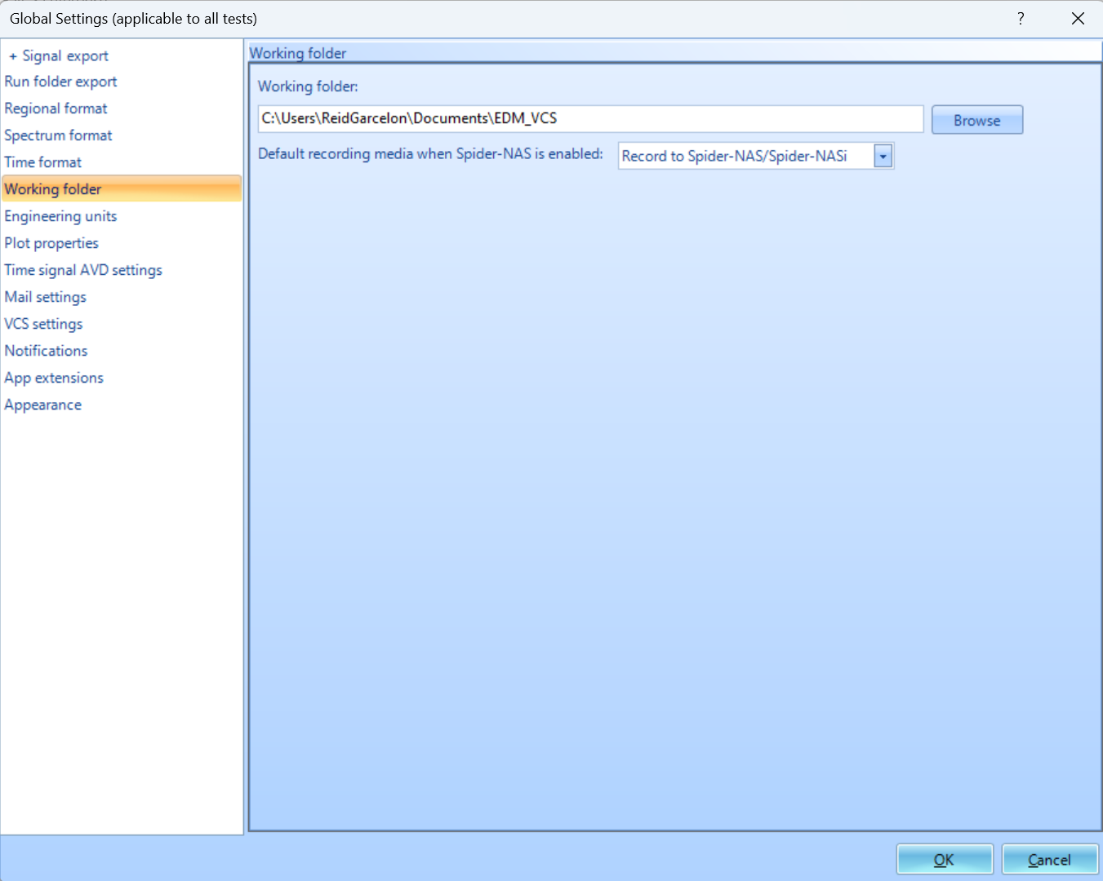

Downloading Data from Spider
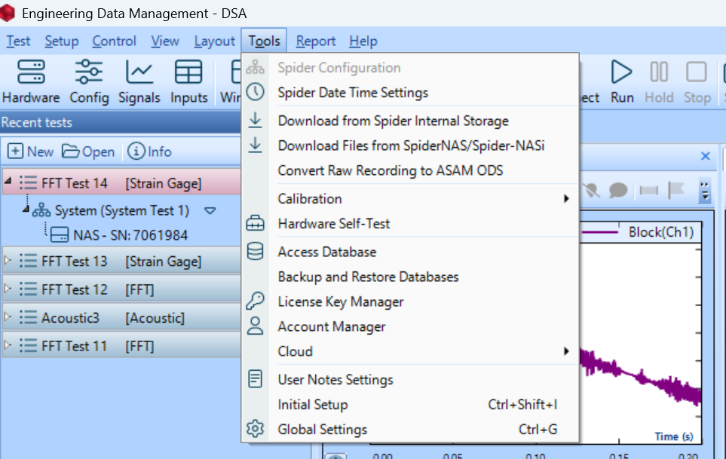
Tools → Download From Spider Internal Storage
- Download/Download Page configures files by Rec and SIG data folders
- Run Log configures data by Test
Tools → Download from Spider NAS/NASi
- Download data recorded to NAS/NASi

Export Data
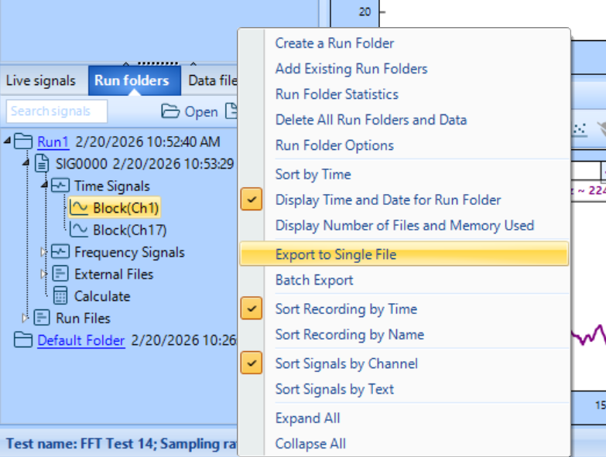
Export Run Folder: Right-Click → Export to Single File
Export SIG/REC File: Right-Click → Export
Export Specific Channel Data: Right-Click → Export

