How to Export Data
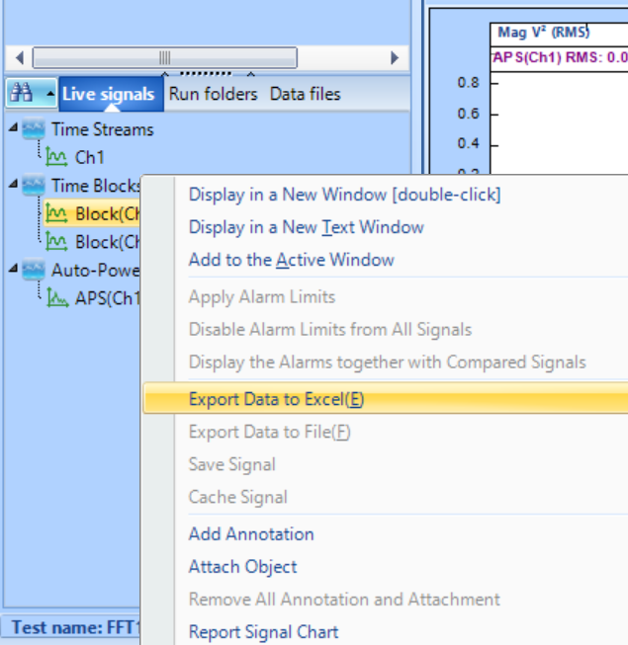
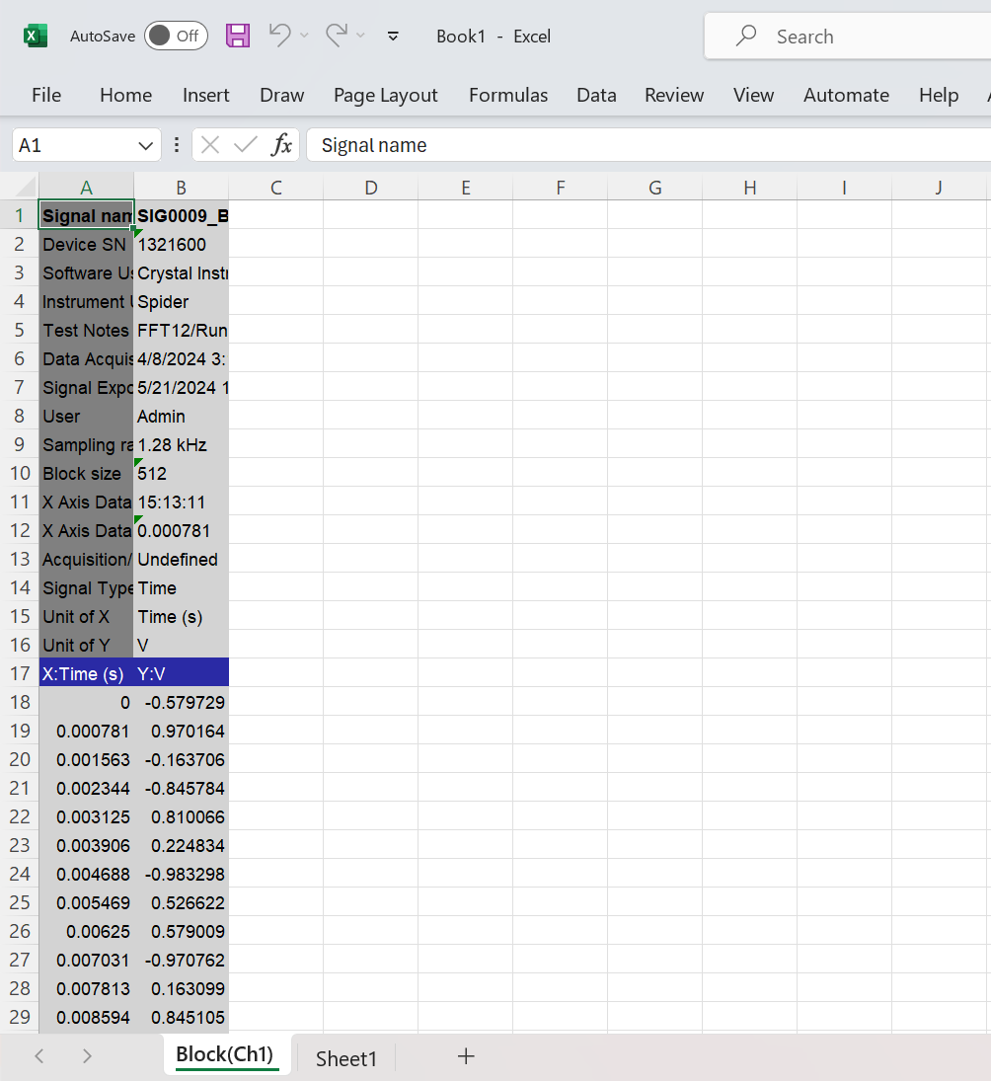
Here is how to export data to Excel from EDM DSA.
1. In the bottom left section of the DSA window, find the signal you want to export under Live signals, Run folders, or Data files.
2. Right-click on the name of the signal you want to export.
3. In the pop up menu, select Export Data to Excel(E).
4. A new Excel file containing the signal data will automatically open. This file can then be saved to whatever location you choose.

