Where is My Data?
The testing data is managed by the CPU on the front-end hardware and PC (or, iPad and other peripherals). The testing configuration and testing results, i.e. the measured signals, can be saved in various locations, summarized in the following diagram:
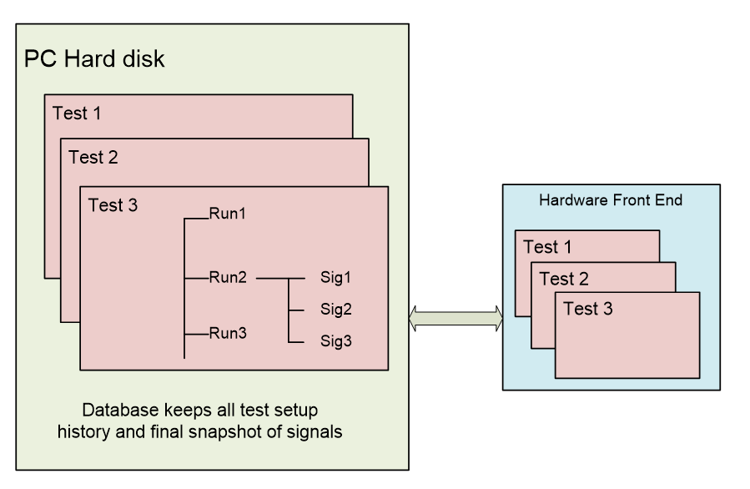
On the PC, the database keeps all the history, testing setup, and the final snapshot of measured signals. If you want to back up the setup of ALL tests, simply back up or export the complete database.
The testing data is organized with a hierarchy of Tests>Runs >Measured Signals.
On the PC, hard disk, a test folder containing multiple RUN folders is also created. A test project file, *.STK is a copy of the test setup in the database with the same test name. It is a single file and can be easily transported to another PC.
The Run folders keep multiple measured signals saved by the user or the test. These measured signals are not stored in the database.
Each file of Measured Signals contains multiple signals that are captured at one time. We call these signals collectively as a frame of data.
If the user sets the Front-End to black box mode or selects to save the Measured Signals to the Front-End instead of the PC, the measured signals will be saved to the front-end hardware instead of the PC. Users can always download the measured data from the Front-End to the PC.
On the front-end hardware, the most recent dozen tests are kept in the flash memory, so the hardware can run without the PC. If operated with the PC, the software will automatically synchronize the test configuration from the PC to the Front-End.

Next: How the User’s Software Reads CI Data Files (ATFX API)
How the User’s Software Reads CI Data Files (ATFX API)

