Installer Logs
If your exe installer is failing, send the logs to CI Support. To do so, open the File Explorer and navigate to:
C:\Program Files (x86)\InstallShield Installation Information
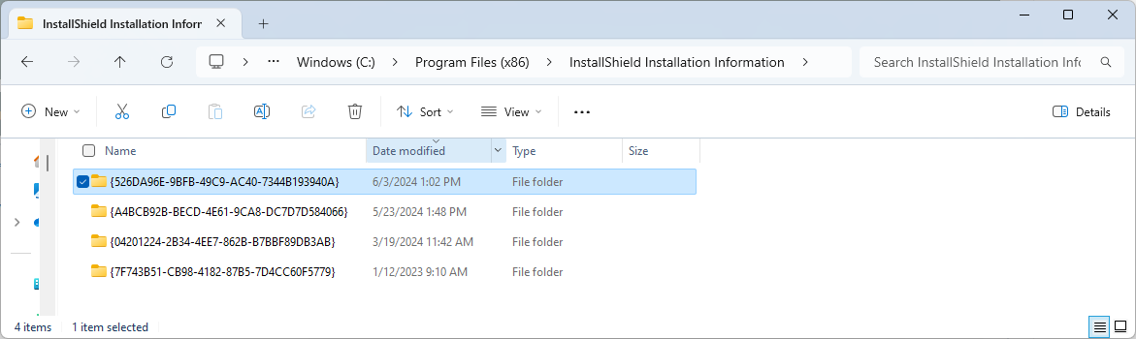
Note: the InstallShield Installation Information folder is a hidden folder, so you need to type or paste this path directly into the File Explorer window.
Pick the folder that corresponds to your installer. You can sort by Date modified and select the most recently modified folder.
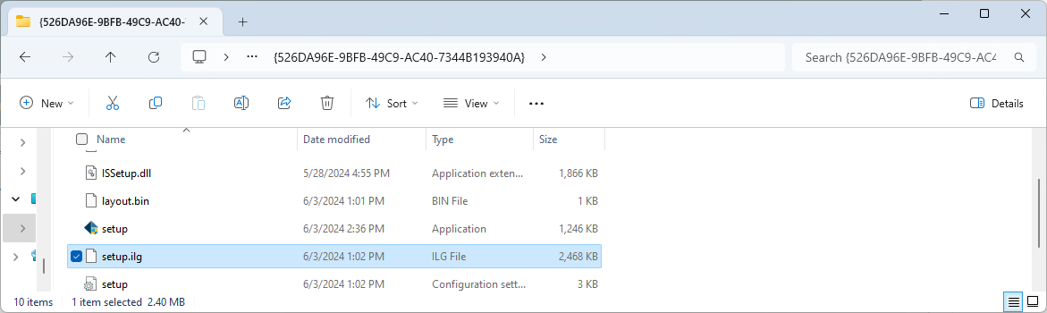
Then, copy the setup.ilg file and send that to CI Support (support@go-ci.com)

Checking setup.ini
If you're not sure you picked the correct folder, you can confirm the correct folder by opening setup.ini and checking the product name: Product=EDM Testing


