Post Analyzer FFT Spectral Analysis
The FFT Spectral Analysis uses applications of the digital signal processing theory for input channel signals with the option to enable data conditioning.
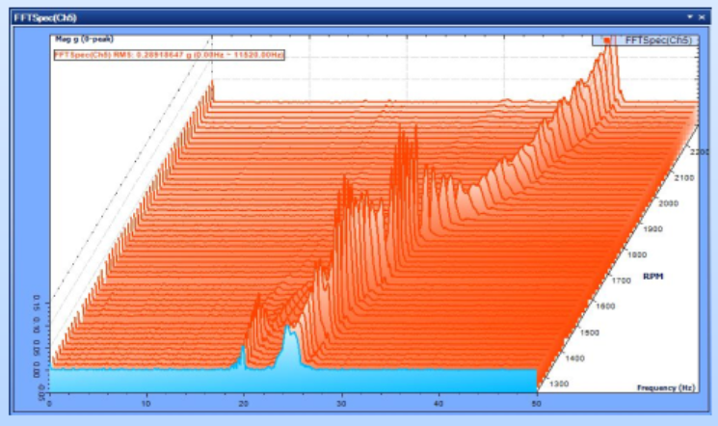
There are several signal computation options available for post processing. The most used options are APS: Auto-power Spectra and FRF: Frequency Response Functions
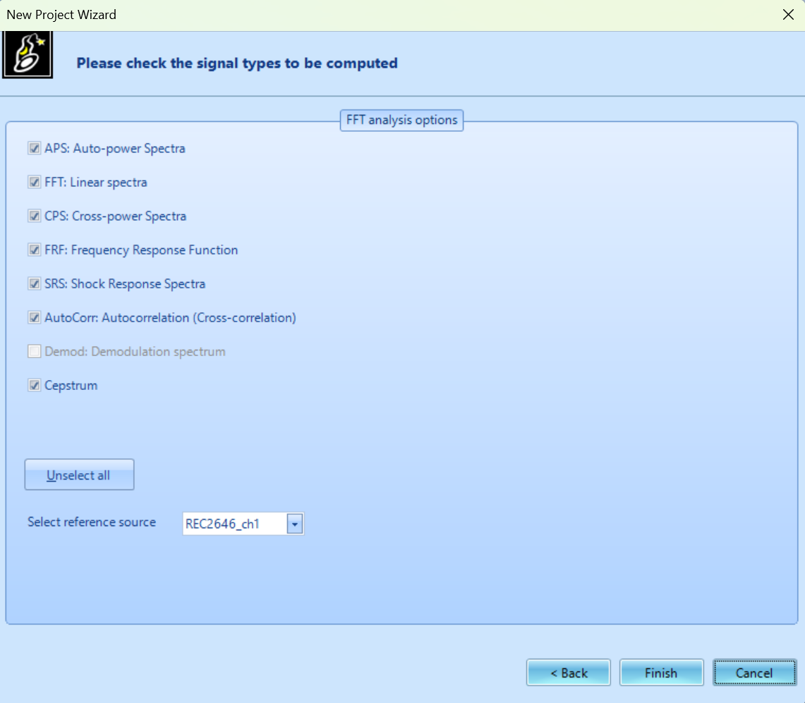
Results of selected options:
Computation of time stream data results are displayed in signal window and resulting plots appear when double clicked or dragged into compatible graph.
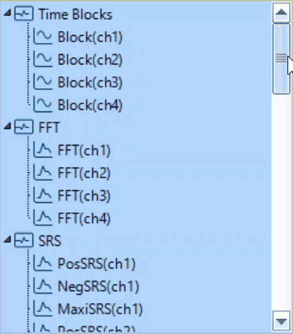
Auto-power Spectra: APS is our in-house terminology for a standard FFT analysis. Displays frequency spectrum corresponding amplitude after FFT and data processing. Typically results are displayed in Hz (Frequency) on the X-axis, EU Y-Axis scaled to dB, LogMag, or Lin Mag.
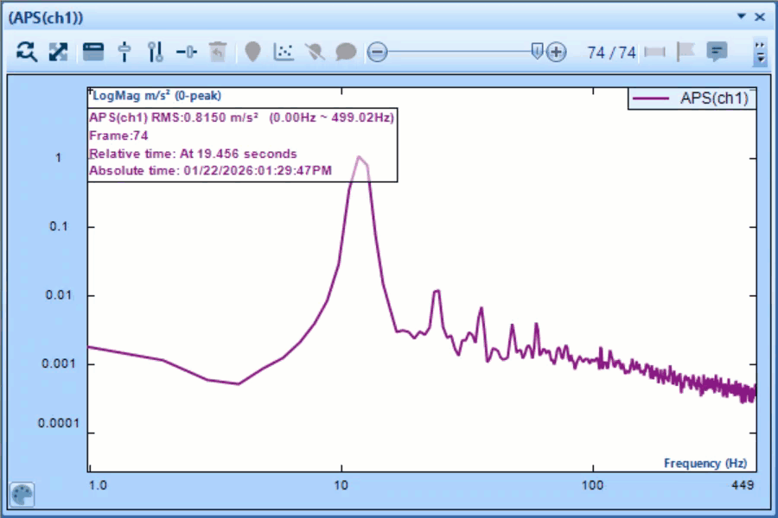
Frequency Response Function: Often referred to as transfer functions, FRF describe the relationship between the input and output functions. Result is commonly displayed in Frequency v Phase & Frequency v EU similar to FFT analysis.


