Post Analyzer License Keys
Upon Purchase of Post Analyzer software, you will receive an email from Crystal Instruments production providing you with a license key code and instructions for where to find the software download.
Dear Customer,
Thank you for purchasing Post Analyzer.
Please visit our website at license.go-ci.com for more details.
Provided is the Post Analyzer code for installation: 12345 ABCDE 67890 FGHIJ 12345 ABCDE 67890 FGHIJ
If you have any technical questions or difficulties, please contact
Crystal Instruments at support@go-ci.com by email
Thank you for your business.
Best Regards,
Crystal Instruments

License Site
All Post Analyzer download links and activation information can be found at our Licensing site.
Crystal Instruments Licenses
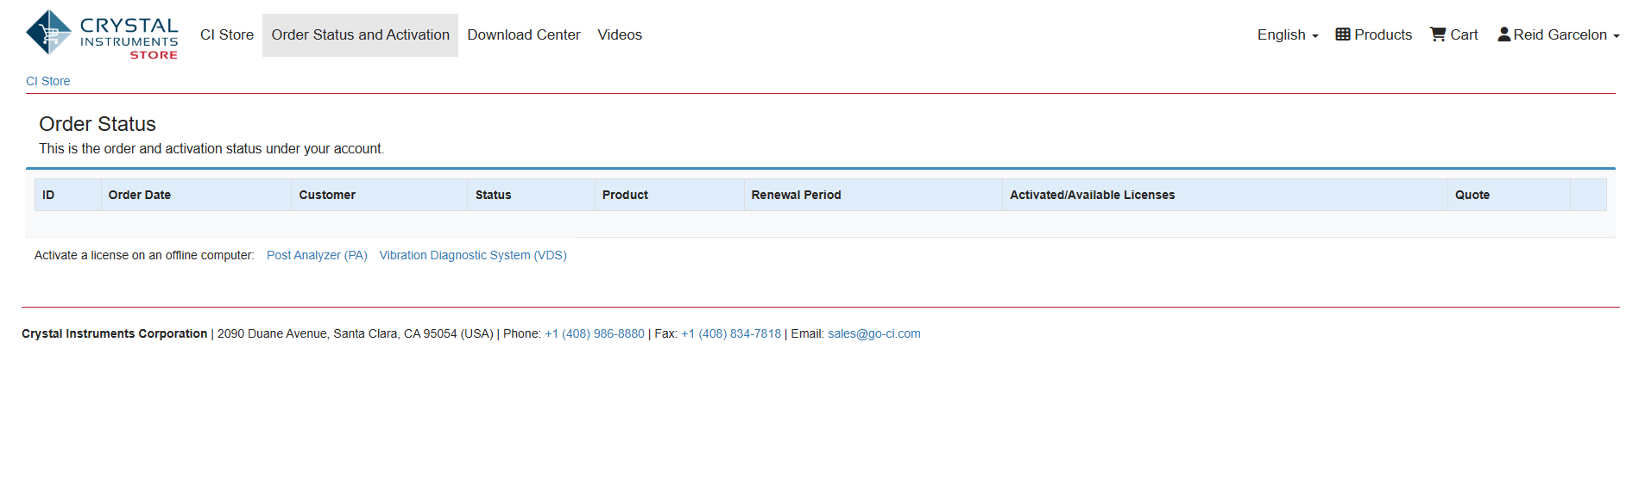
Your order and license information will appear under the Order Status & Activation tab.

Available Licenses
Your order will include a number of available licenses. These are activated to a PC and will keep you logged in and able to access Post Analyzer on a PC until it is deactivated.

License Key Activation
Copy and paste the key provided to you into the software activation tab.
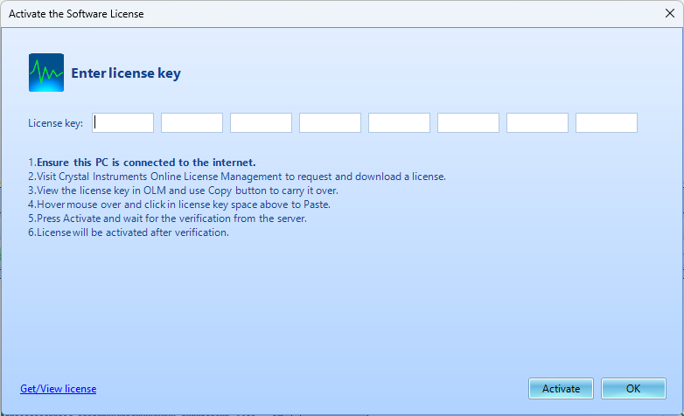


Offline Activation
If you need to activate the Post Analyzer license on a PC that doesn't have access to the internet then you can follow the offline activation procedure found at:
PA Offline Acitvation
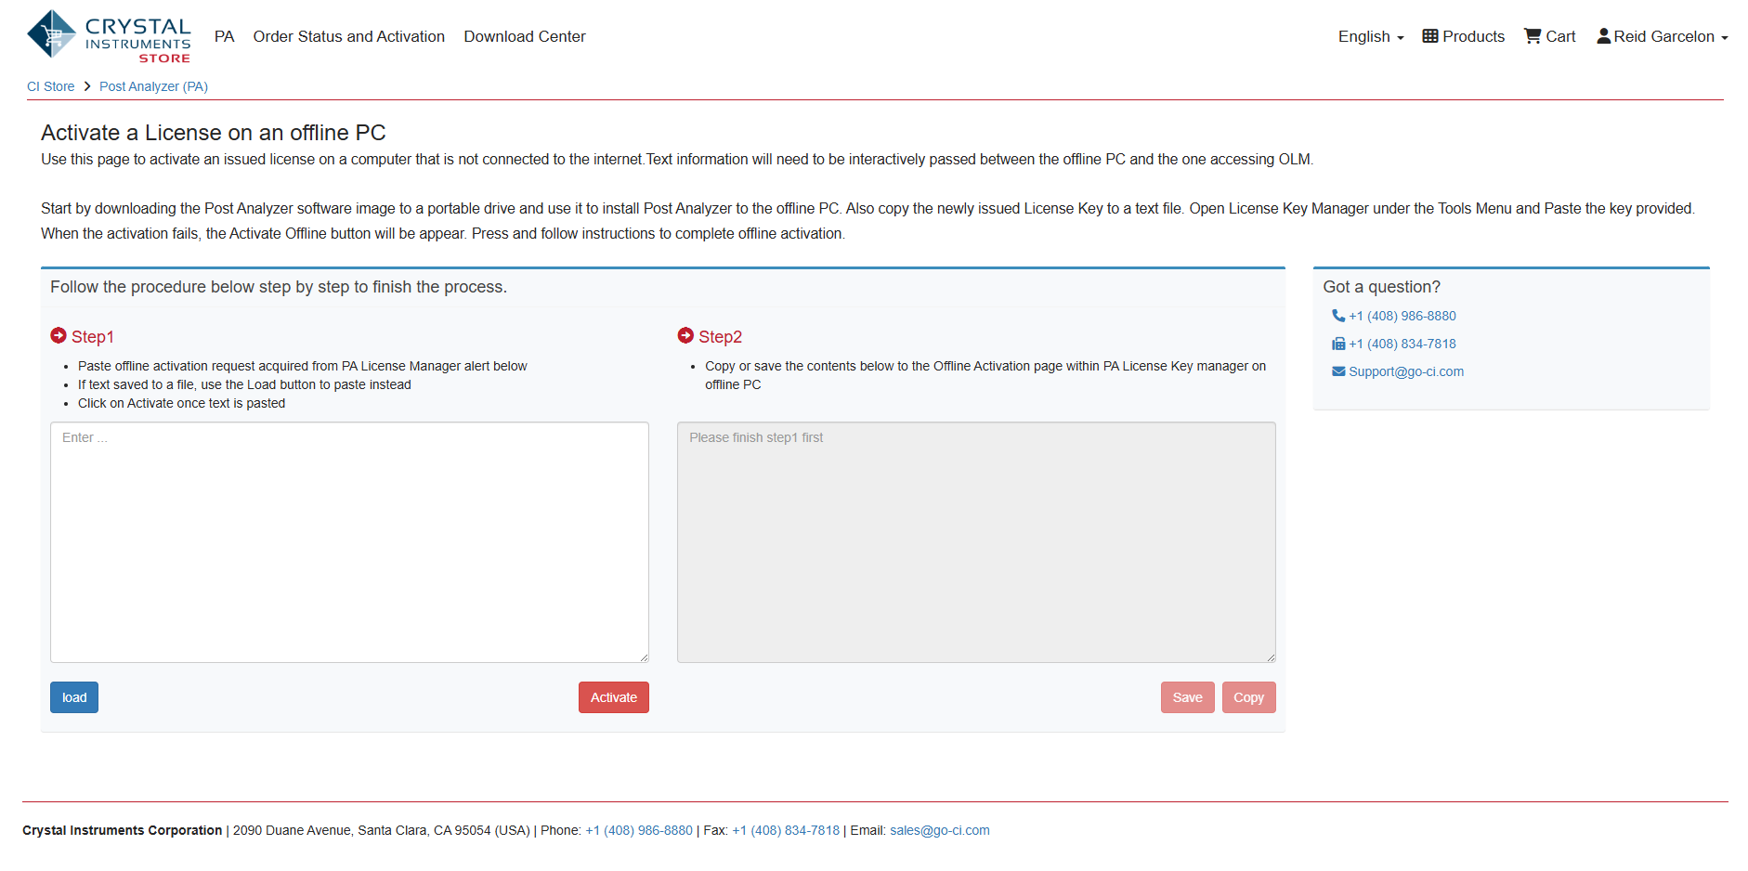

License Key Deactivation
To deactivate a license, go to Tools → License Key Manager and click on deactivate in the bottom right corner of the Activate the Software License tab, then click Yes to deactivate the license. You can now connect Post Analyzer to a new PC using the same license, but only the number of available licenses under your order can be connected simultaneously.


