Running Post Analyzer
User guide can be found through the Help tool on the ribbon:
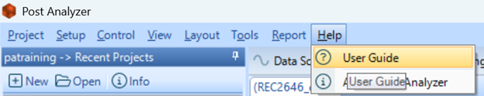
User guide is a fantastic and easily navigable resource to help guide you through the process of using and understanding Post Analyzer:
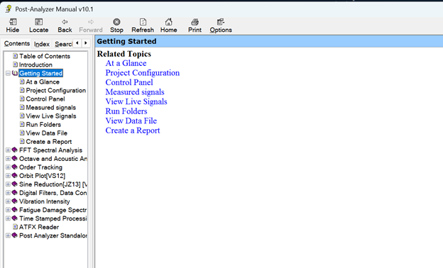

New Project

Analysis Type
Projects store analysis settings and are associated with specified data files. There is no limit to project creation but only one can be active at any time per instance of PA. Project wizard and test selection screens may differ from those shown below based on bundle and testing options purchased on license.
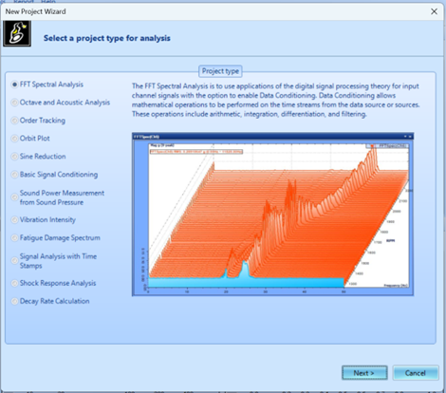
Project creation begins with the selection of an analysis type. There is a strong possibility that you know and understand your testing parameters and requirements, in that case select the option that best fits your needs. Test description is provided when the corresponding bubble is left clicked. Additional information can be found on our reference materials site.
Test & Measurement
If you are unable to find the test type which meets your requirements, contact support@go-ci.com for support or technical info.
Click Next > after desired test type is found.

Data Source
Set project name and description and then select a template if you would like to create your project from a previous save state. Then select your data files from the source file browser. To upload .atfx .csv .txt or .tdms files from your PC, click on Add single source file. To browse files in your EDM select Data File Browser. Click Next > to continue to analysis options.
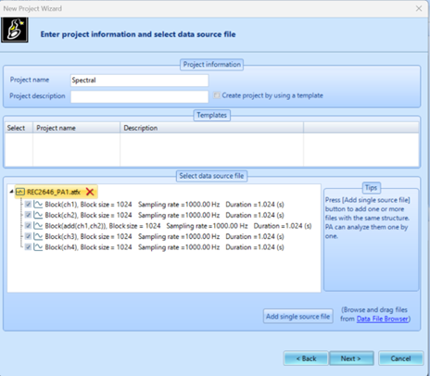

Signal Computation Selection
Figure displays options for an FFT analysis, options will vary depending on test type. APS and FRF are the most used analysis types. APS is our internal term, Auto-Power Spectrum, it is what is commonly thought of as an FFT power spectrum and has a wide array of applications. FRF are sometimes called transfer functions and describe the relationship between input and output. Reference channel will default to time stream data from channel 1 of the data source provided from previous step.
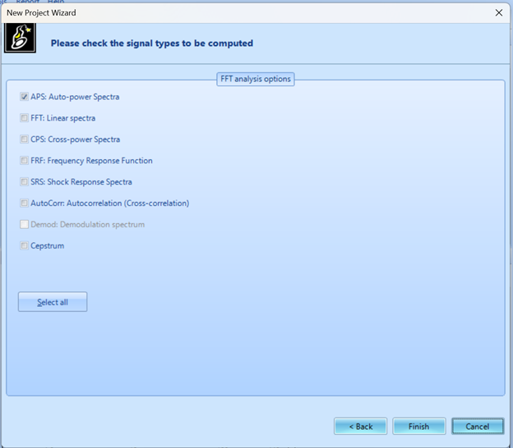
Click Finish to complete project wizard setup.

UI & Tools
Once the project is loaded, the signal display window will appear by default. When first loaded into project, only the time stream data/data source files selected for analysis, will be present. Data source tab will also be opened by default. Channels can be toggled on or off if desired under this window.
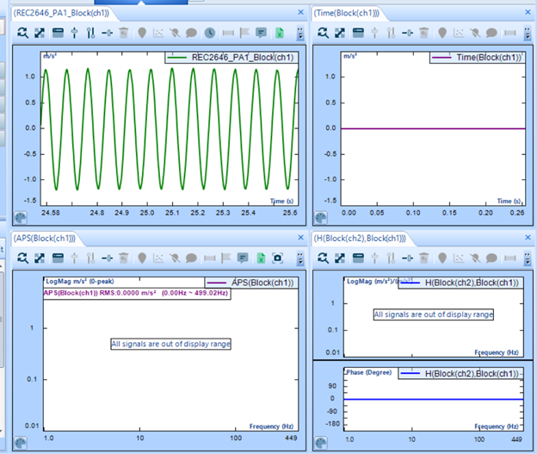
Current and previous tests will be displayed in the Recent Projects window on the upper left of the screen. This window allows easy interchangeability between projects. Live signals, Run folders, Source Files are displayed in the bottom left window.
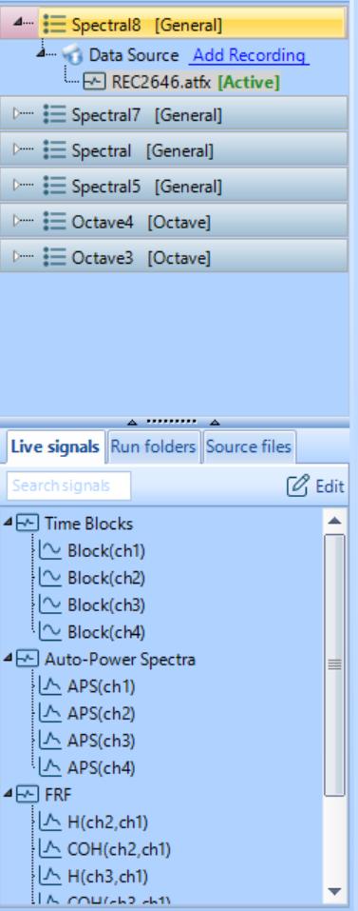
From this window, the time streams and computations which are needed for your testing requirements can be placed in signal display window.
Before running test, select Setup drop down from ribbon and left click Project Configuration.
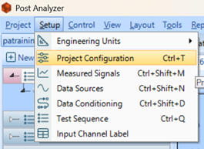
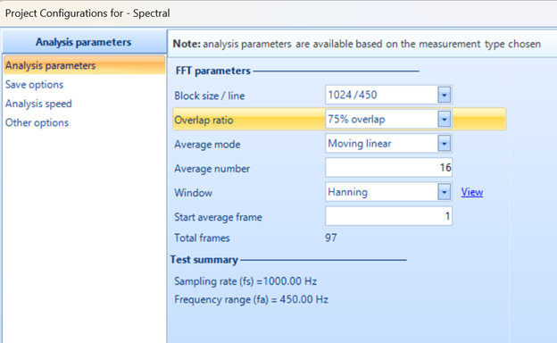
Make selections for block size / spectral lines to determine ∆f and dynamic range. Overlap ratio, recommended at least 50% for Hanning window. Average mode and average number should be adjusted based on testing requirements, if no direct requirements to change these settings leave as default. Applying a window to the data has a smearing effect which allows for the signal to be treated as periodic within time blocks. Each window type has slightly different properties, Hanning is good for precisely distinguishing between different sine waves. Flattop windows are good for identifying peaks. The data Window selection can be left as Hanning for most testing applications; Uniform may be desired for shock or transient impulse testing.
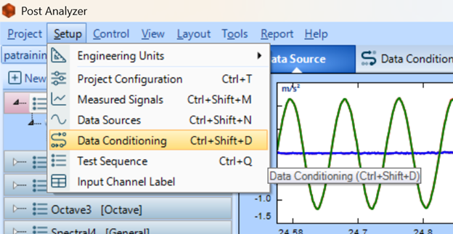
pa-data-conditioning
For further processing options select Setup drop down and left click Data Conditioning. Data conditioning capabilities are supported for FFT Spectral Analysis, Time-stamp, Order-Tracking, Sine Reduction & Basic Signal-Conditioning analysis types. Data Conditioning supports functions to control and process data using a logic gate structure.
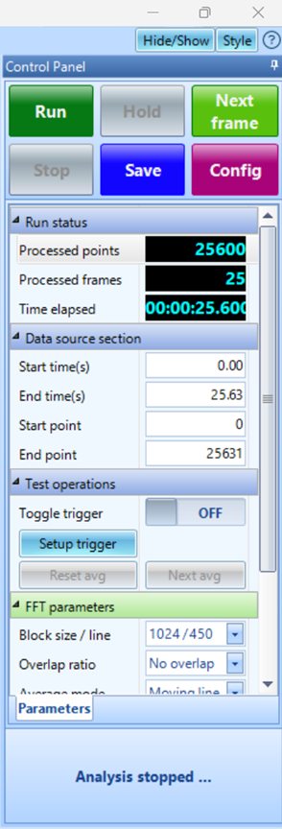
Right of the Display window is the Control Panel. The main testing drive operations are found in this section. As well as test configurations and parameters. Many of which are shared with the Setup → Project Configurations dropdown box.
Once setup is complete select Run from the control panel in the upper right of the screen.
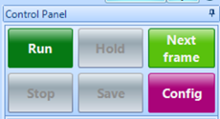
During testing the options of: Hold, Next, Frame, Stop & Save will become available. If held (paused) the continue option will be present.
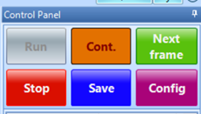
Processed data will display in windows and be saved to signal folders as the signal is run in real time. Save option in Control Panel will become available to user.


