Real Time RMS
The Real Time RMS page can be accessed by connecting to a Ruby via Bluetooth, where it shows the numeric display.
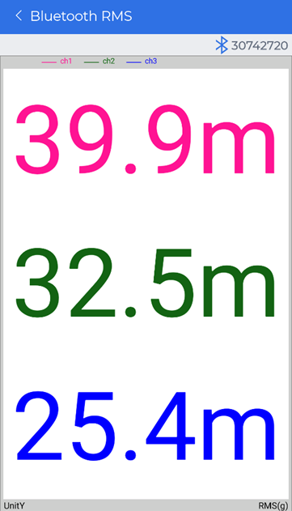
For more details on how to move and zoom around in the signal display, see Moving and Zooming around in the Signal Display Traces or Navigating Signal Display Controls.

