Local Files
The Local Files page is the phone’s local storage of all the signal data files downloaded from the Rubies.
Each file in the list can be tapped on to view the signal data.
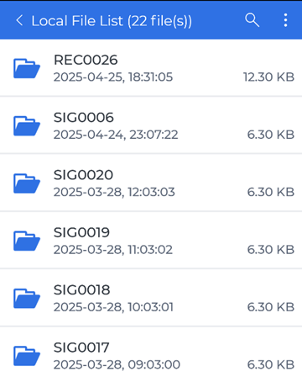
Each file in the list can be slide to the left to reveal a red Delete button to selectively delete a file.
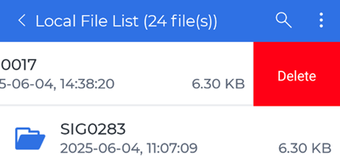
There are three icon buttons on the top blue bar:
- The back button to go back to the previous page located on the far left
- The search button to find a specific file by name
- The file operation menu opener button that will open a menu at the bottom of the page and enable checkboxes for each file element
  - The bottom menu bar will have two buttons to select all the files in the list and delete the selected files in the list
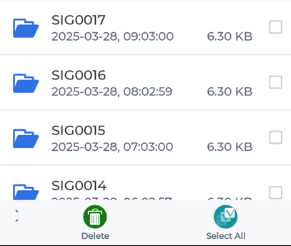
For more details on controlling the signal display traces, see Moving and Zooming around in the Signal Display Traces or Navigating Signal Display Controls.

