Creating a Schedule in the Ruby Mobile App
If a Ruby device does not have a schedule uploaded to it from EDM RCM, it can be created in the mobile app and uploaded to the Ruby.
Go to RCM on the main page then Schedule then Create New Schedule.
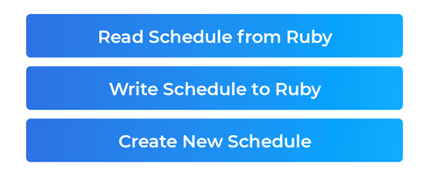
This will create a Schedule 1 that can be tapped on to edit various settings. For more details regarding the settings, see RCM > Schedule. After editing the settings, back out and tap on Write Schedule to Ruby to upload the schedule.

