Moving and Zooming around in the Signal Display Traces
Each signal trace on a signal display page can be moved and zoomed around.
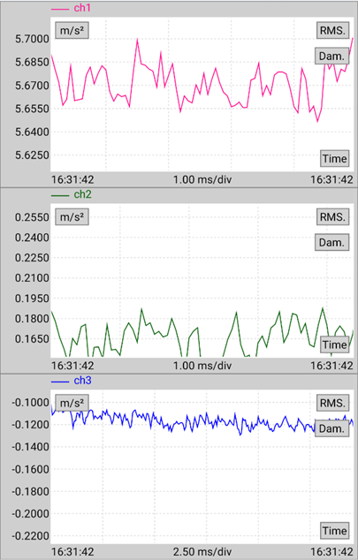
There are two ways to control the axis ranges:
- Zooming in and out via two fingers by pinching or expanding
- Tapping on the X or Y axis to set Auto range or a specific range
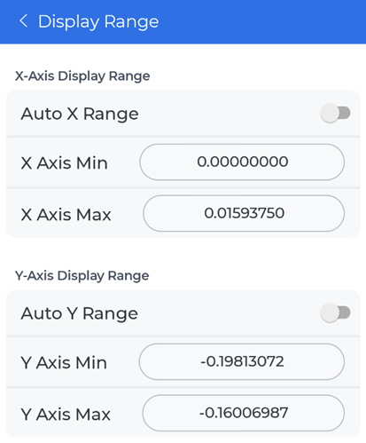
For more details on controlling specific signal display controls, see Navigating Signal Display Controls for Android or Navigating Signal Display Controls for iOS.

