RCM
The RCM page has additional pages and functions that relate to the EDM Remote Condition Monitoring software. When a Ruby is connected, there will be two additional buttons:
- Schedule
- Meas. Entry
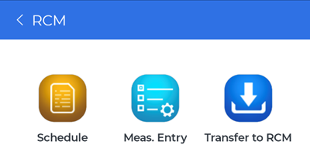

Schedule
View and change the current schedule and entries stored in the Ruby that determines when the Ruby save signals. If there is no schedule in the Ruby, it can be created through the mobile app.
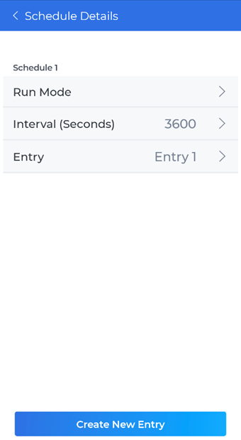

Run Mode
A schedule can have several run modes that determines when the ruby starts saving signal data.
- Loop with Time Reached
  - Save signal data every interval once a set time has been reached
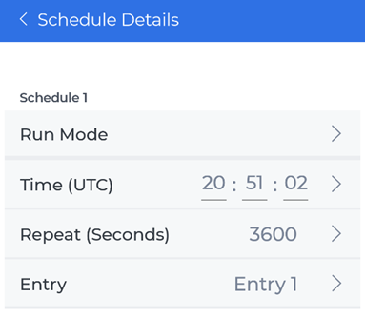
- Loop with Interval
  - Save signal data every interval once the schedule is uploaded to the Ruby
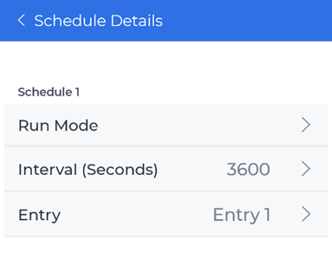

Entry Details
A schedule entry has three details that can modified:
- Type
  - Save Signals: Save a signal frame
  - Record Signals: Record a signal according to how many points or duration
- CSA: Select a Measurement Entry that the schedule entry will use
- Depending on Type
  - Run Frames or Points / Duration
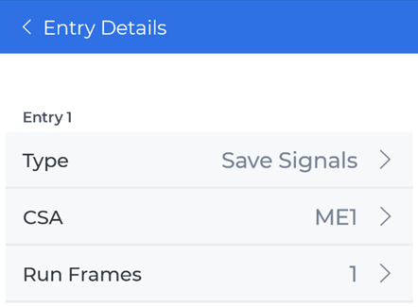

Meas. Entry
View the measurement entry details that are uploaded to the Ruby as part of the schedule.
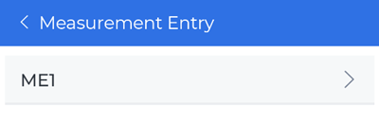
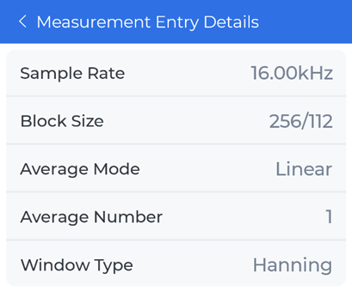

Transfer to RCM
The Transfer to RCM page is to transfer locally downloaded signal files in the phone to RCM. There are instructions on this page for users to follow, but if more details are needed, see Downloading Files from the Ruby to RCM.

