Settings
The Settings page can be accessed via tapping the gear icon on the ruby mobile app main page.
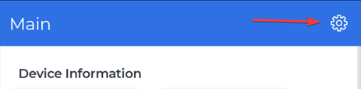
There will be three buttons:
- About
- Theme
- Language
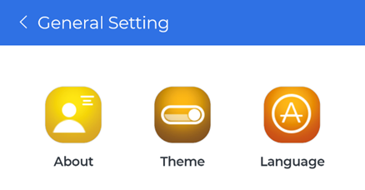
The About page will show the ruby mobile app version and information about Crystal Instruments.
The Theme page provides two options for changing the ruby mobile app UI colors.
- Light theme
- Dark theme
The Language page provides options to change the ruby mobile app language.

