CAN-Bus Aborts for Shaker Testing

OVERVIEW
The CAN bus (Controller Area Network bus) protocol is a peer-to-peer communication standard for automotive devices without relying a complicated central computer. It is configured with two wires (CAN high and CAN low) which vary in voltage to communicate a bit series of 1’s and 0’s. CAN bus was initially designed in 1990, with the ISO standard released in 1993. Using CAN bus, an electronic car component (ex: car battery, engine control unit, etc.) can communicate any arbitrary data such as its temperature or working status. A DBC file is used to encode and decode the 1’s and 0’s into meaningful data, which can be a different mapping for each customer. EDM supports integration with CAN bus signals for monitoring and Alarm / Abort purposes. Given a customer’s DBC file and custom-built Crystal Instruments USB CAN adapter, CAN bus alarm and abort rules can be configured during a vibration test. For example, a User running vibration tests on an EV battery can now configure EDM to monitor the battery’s temperature and stop or pause the test when the temperature matches or exceeds a particular value.
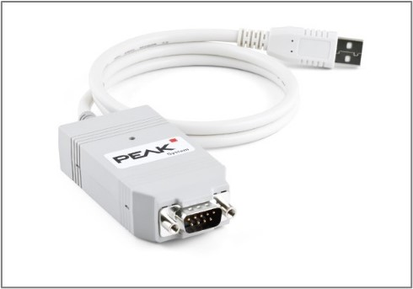

CANBus Interface In EDM
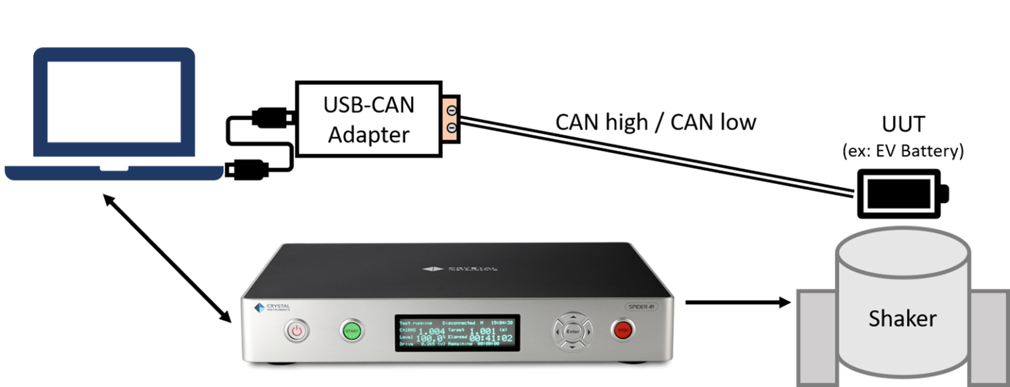
To read CAN bus signals from the UUT, first connect the CAN Bus USB adapter to the PC running EDM. On the other end of the CAN bus adapter, use the screw terminals to connect the CAN high (CANH) and CAN low (CANL) wires in the CAN1 section. The adapter should light up upon detecting CAN bus signals.

Driver for PCAN-USB Adapter (PEAK SYSTEMS)
When using the Peak Systems USB adapter, please refer to the Peak Systems website to download necessary drivers and documentation. This step should ideally be done before proceeding further and interfacing with EDM.
Peak Systems website URL: https://www.peak-system.com/PCAN-USB.199.0.html?&L=1
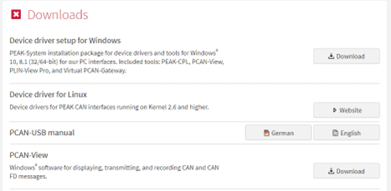

Configuring CANBus On EDM
Click on Setup > CANBus to open the CAN-Bus window, which contains all settings and functionality related to CAN bus.
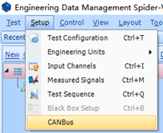
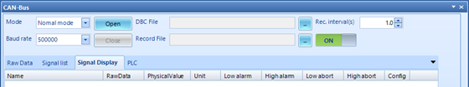
There are several modes that can be used for the CAN-Bus window
Normal mode: Used when connecting the Crystal Instruments CAN-Bus USB adapter to the PC running EDM. If the USB adapter is installed, you should be able to click Open to locate the DBC file in the filesystem
Listen only mode: A similar mode as “Normal mode” where only CAN-Bus signals can be listened to (no sending allowed).
Self-test mode: Used when connecting the Crystal Instruments CAN-Bus USB adapter without a CAN-bus node on the other end. Provides a convenient way to “self-test” certain CAN-Bus signals arriving over the wire.
PCAN-USB: Used when connecting the Peak Systems PCAN-USB adapter to the PC running EDM. If the USB adapter is installed, you should be able to click Open to locate the DBC file in the filesystem.
Baud rate: The rate at which data is transmitted over the network. Must match the Baud rate of the external CAN bus device.
DBC File: The .DBC file that describes the data transmitted over CAN bus. Necessary to decode the bits into meaningful information.
Record File: Specifies the file location for storing recorded CAN bus data (can be turned ON or OFF).

Viewing Raw Data in CANBus
The Raw Data tab in the CAN-Bus window shows a stream of incoming raw CAN bus data. For instance, in the below image, we can see that multiple data sets can be received from a CANbus and each of them is associated with an ID and the data being transferred.
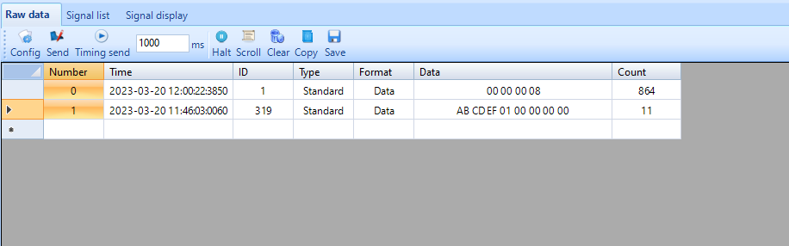

Sending Data in CANBus
Below the Raw Data tab is a configuration for sending CAN-Bus data. Click on Config to open the “Send Configuration” window.
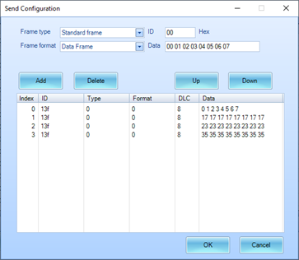
Frames of CAN bus data can be configured with the desired ID (in Hexadecimal) and Data body.
Frame type: supports “Standard frame” and “Extended frame”
Frame format: supports “Data Frame” and “Remote frame”

Signal List in CANBus
The Signal List window visualizes the uploaded DBC file as a human-readable list of nested entries.
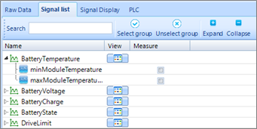
Filter through the signals in your DBC file using the Search box above. Click on the View icon to see more details about the configured CAN bus entry. Enable the Measure checkbox to enable it in the Signal Display tab.

Alarms and Aborts in CANBus
The Signal Display tab lists all the CAN Bus signals which have been enabled by checking the Measure checkbox. This is the page where the CAN bus values can be configured to trigger a “CANBus Abort” or “CANBus Alarm” event that will be handled later in Event Action Rules. For instance, in the below image, the test will abort when the physical value exceeds the High Abort Value.
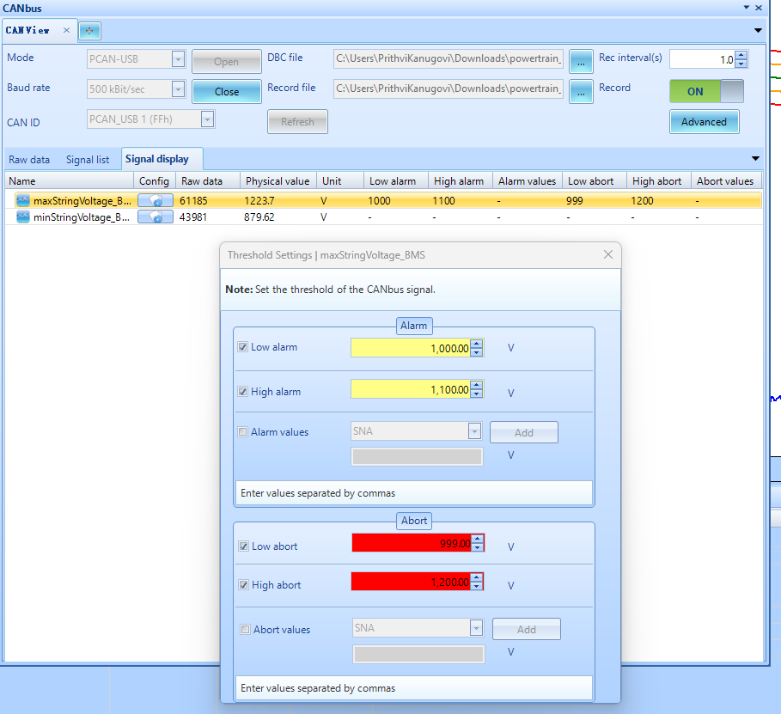
Click on the Config icon for each given entry to configure the Alarm / Abort thresholds.
Low and High limits are supported, as well as matching for custom values (“Alarm Values” / “Abort Values”).
Simple mode: For a simple enlarged view of the limits, right-click on the entries and select “Simple display mode”
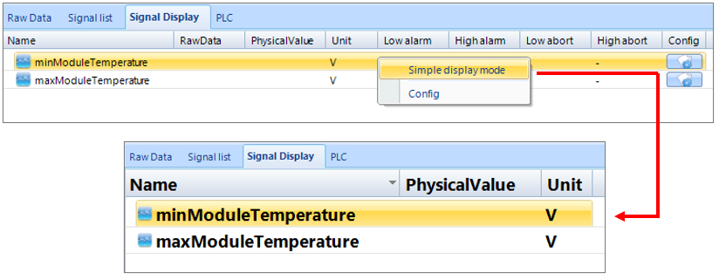

Event Action Rules in CANBus
Use the Event Action Rules page under Setup > Test Config to finalize the downstream actions for EDM to take once a CAN bus Alarm or Abort has been triggered. Event Action Rules refers to an innovative feature developed by Crystal Instruments offering the flexibility to define arbitrary actions when certain events happen. When CAN bus is enabled, two additional Event names will appear: “CAN-Bus Abort” and “CAN-Bus Alarm”. These event names correspond to the Alarm and Abort criteria configured in the previous section.
Click on Add action, Edit action, or Remove action to further configure the list of actions for EDM to take after an Abort or Alarm is enabled.
This is the final step in the CANbus configuration. EDM is now ready to interface with CANbus data and take necessary actions such as Abort or Alarm during the tests.


