Spider Check List
This window allows the user to confirm all the settings and make any last-minute changes. The window has sections for pre-test settings, shaker information, test level and duration information, and input channel configuration. Most of these channels can be edited by clicking on the blue underlined text. There is also a section for adding custom report fields and a test description.
Before any test is ran, the Spider checklist will appear. It can also be accessed by going to Test > Checklist or Ctrl+Shift+K to open the window.
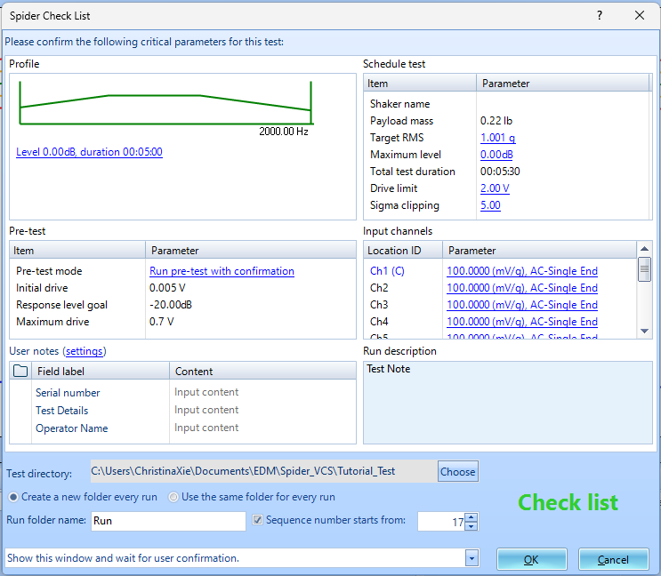
Run Schedule, Test Profile, Pre-test Parameters sections can all be found in the control panel clicking the Config button.
Input channels window can be found going to Setup > Input Channels or Ctrl+I.
User Notes will be found in Tools > User Notes Settings. Here, important key data characteristics and values can be added. These fields (such as DUT, Serial Number, Test Method, etc.) can also be automatically attached to the Run Folder to help with documentation and organization. The Field Labels are also customizable, so if there are additional data values that need to be added, click Insert and then type in the textbox.

