VCS Test Types
EDM VCS Supports a multitude of independent test types which are selected upon test creation. Test types provide support for various control profiles and testing requirements.
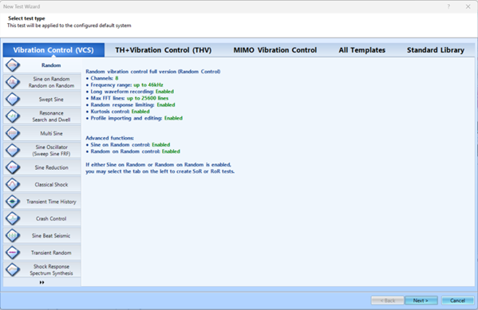
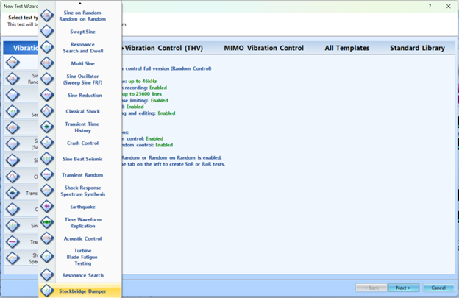
Random
Random excitation is often used to simulate real-world vibration. The purpose of the random vibration control system is to generate a true random drive signal such that, when the signal is applied via an amplifier/shaker to the device under test, the resulting shaker output spectrum will match the user-specified test profile. VCS also has the capability to perform Sine on Random (SoR) and Random on Random (RoR) testing.
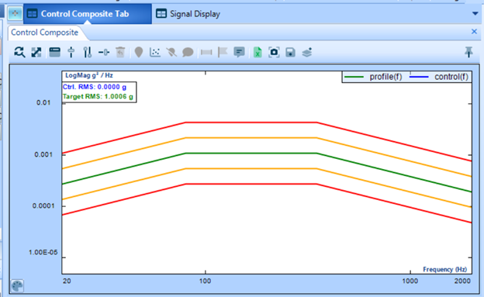
Swept Sine
Unlike Random testing which generates many frequencies at once over the band of interest, Swept Sine testing generates energy at one frequency. User defines profile of sine wave which is swept across frequency spectrum at the strength and speed of choice.
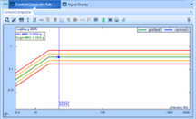
Classic Shock
A Shock test outputs a series of pulses to excite the structure under test. The response is measured at one or more locations on the structure and a spectral analysis is used to determine its response and resonance characteristics. This pulse response approximates the impulse response, the theoretical response to an infinitely tall and narrow spike function with an area of unity. Signal input is a pulse with adjustable shape and magnitude. User defines interval and number of pulses.
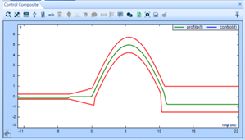
Resonant Search and Dwell (RSTD)
System uses an FRF saved from a previous test to find the resonant frequencies, peaks and optionally valleys, of the UUT. The resonant frequencies are then subjected to dwell tests where the UUT is excited under those frequencies to study fatigue and stress on the UUT. Control profile closely resembles swept sine test.
Multi Sine
Signal is composed of multiple sine signals which are simultaneously swept across a spectrum of frequencies. Allows resonant search to be conducted across large bands in a significantly shorter time period.
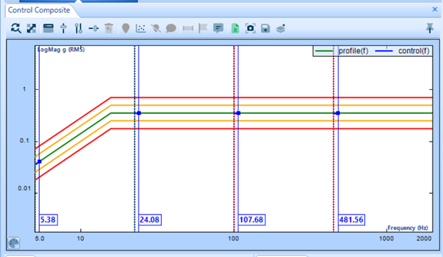
Sine Oscillator
Signal is controlled by user, drive voltage and sine tone are manually set. System will run in open loop or simplest closed system.
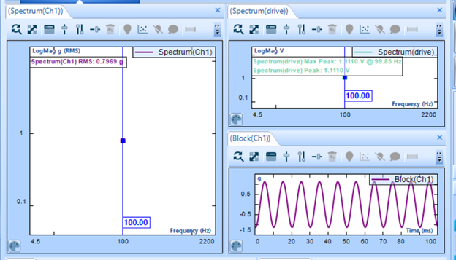
Transient Time History (TTH)
Pulses defined by periodic signal under closed-loop control. The waveform is repeated a predefined number of times and often undergoes a ramp up and ramp down process. Common pulse types are sine-beat, door-slam, decayed-sine & sine-burst.
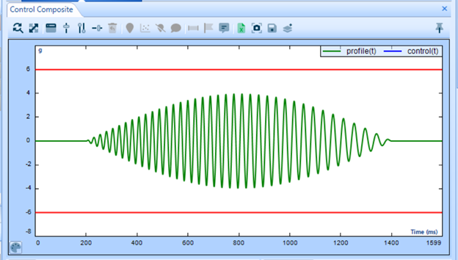
Crash Control
Specialized shock test with tuned pulse limits to conform to vehicle incident standards, test leaves the armature displaced after each pulse, and a manual single pulse workflow.
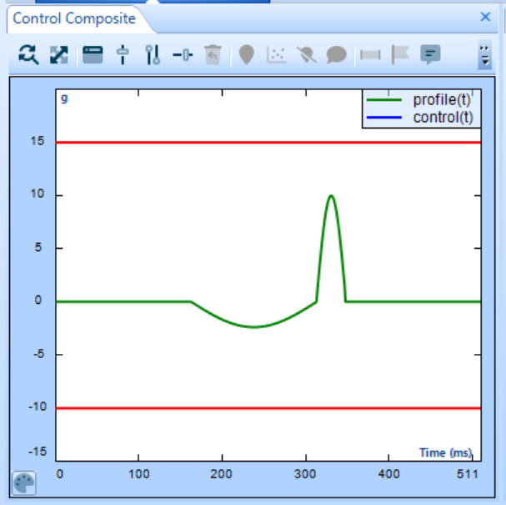
Sine Beat Seismic
Signal is comprised of many sine-beat pulses at varying frequencies and sums the SRS response to form an expected result.
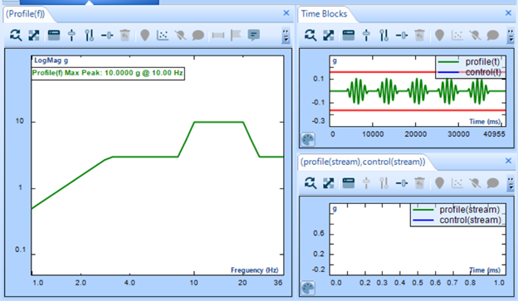
Transient Random
Pulse type test made of random transient blocks of signal with sharp ramp up and ramp down skirts. UUT experiences many random impacts. Interval between tests in predetermined and not randomized.
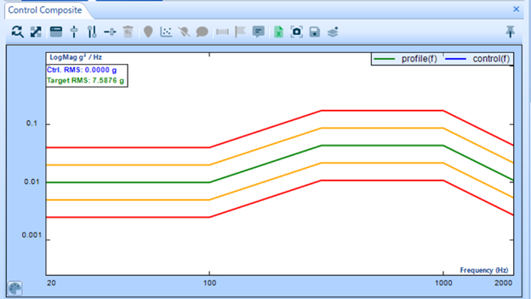
Shock Response Spectrum Synthesis
Shows the response to a user defined input which represents the peak acceleration of a SDOF system with infinite number of natural frequencies. Shows the potential to cause damage of a transient pulse.
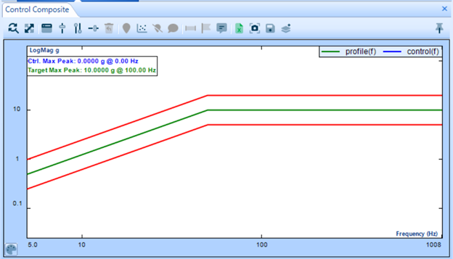
Earthquake
System creates a time-domain waveform to match a shock response spectrum to a required response spectrum (RRS) Time Waveform Replication: Reproduces signal uploaded to EDM. Signal gathered on site can be used in repetitive testing on a shaker offsite.
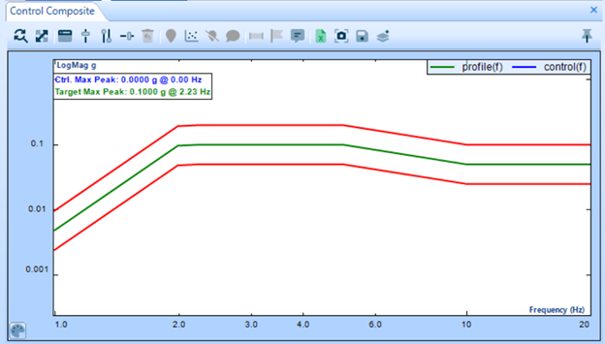
Acoustic Control
Provides control of the high-level noise testing for reverberation chambers and progressive wave tubes. Blade/Turbine Fatigue Testing: Uses resonance search and dwell testing under realistic conditions to reproduce high fatigue in blades.
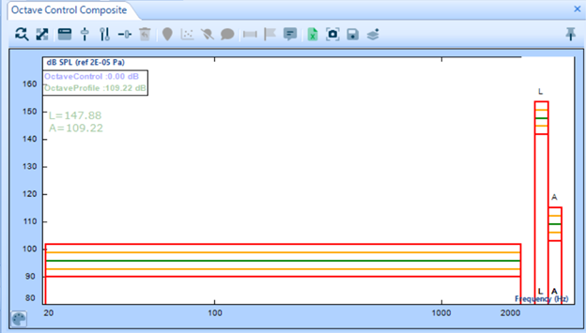
Stockbridge Damper Testing
Test type follows DLT 1099-2021 and IEC 61897-2020 standards. Test is developed for the purpose of evaluating damper effectiveness based on excitation force and velocity response.

