Raw Time Stream Recording Setup
1. Navigate to Control > Record Time Streams. This will initiate the raw time stream recording for all active channels + drive channel.
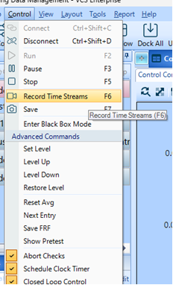
2. On the control panel on the right, click on “Rec”
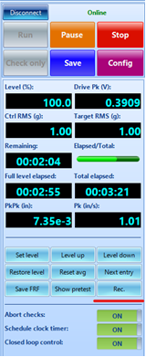
3. There is also a method to automatically initiate the start and stop recording entries for a test. For this, please navigate to Test Config > Run Schedule and add the Start and Stop recording entries to the schedule itself, like below. In the below example, the Spider device will record for the 5mins at the 100% test profile level -
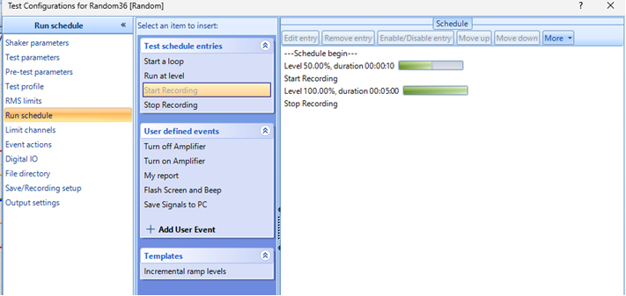
Once the recording is made and the test is completed, you will need to download the recording from the Spider device to your PC to view the recording. For this, navigate to Tools > Download from Spider Internal storage and select the recording you would like the download. Once the download completes, the recording will be available to view under the “Run Folders” –


