VCS UI Config
Configuration tools are generally similar across testing types. The displayed configuration tab is from a random test type.

Shaker Parameters
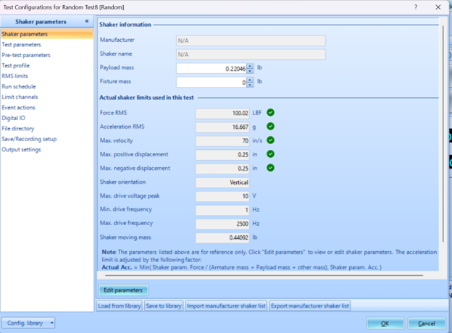
Edit Parameters allows you to adjust the shaker limits in acceleration, force, and displacement.
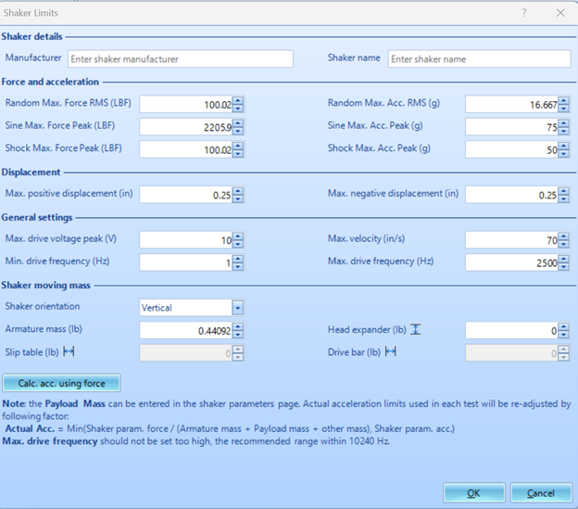
Limits can typically be found through OEM site or product specification sheet. The acceleration limits may not be provided but can be calculated automatically in this interface. The Save to library option will allow for the shaker to be saved for future use & can be set to be the default test settings.
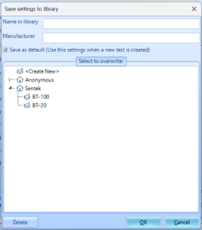
If the shaker in use is not set as default but has already been used in testing, shaker parameters can be imported through the Load from library option located on the bottom ribbon of the page. List of Shaker parameters from OEM can be imported to fill out library.
Test Parameters Testing parameters shown in figure display a random signal test. The test parameters will vary by test type. All test types conducting an FFT analysis will include options for blocking and windowing.
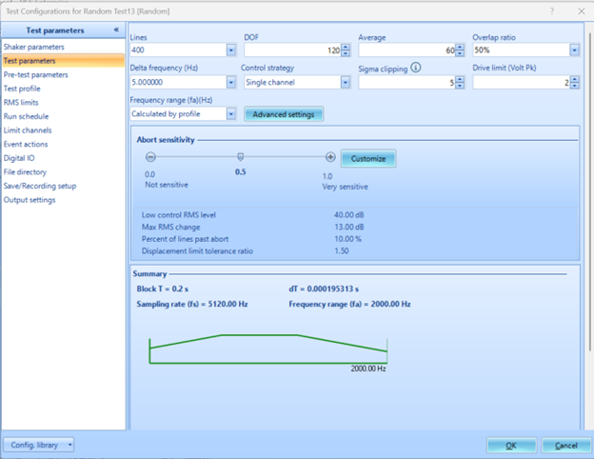
Lines selection box will allow you to choose the spectral lines within a given block. DOF, degrees of freedom, is the number of independent FFT contributing to a statistical result in a PSD diagram. Increasing DOF gives higher statistical confidence in an accurate result but increases computation time. Used for shaker control.
Average is the number of blocks of data that are used to compute a PSD. Averaging can include different forms of weighting and often has overlapping and windowing which contribute to the data not being independent from each other.
Overlap ratio describes how much data from the nth block will be contained in the n+1 block. At 50%, recommended for Hanning window, half of the data in the n+1 block will be new and half will be left over from the previous block.
Delta frequency (Hz) also known as frequency resolution is the spacing between spectral lines and is often referred to as FFT bins. It is the amount of definition able to be seen in an APS spectrum.
Control Strategy; There are four options for this parameter. Single channel control allows the shaker to be controlled by a single monitor feeding into its control loop. Weighted averages the average of all control monitors and sets the control to be the mean of the inputs. Maximum takes the highest control output at each spectral line and sets the control output based on these inputs. It is used when care is taken not to overexcite the UUT. Minimum is the reverse and is used when the UUT needs to make sure to meet a minimum excitement criterion.
Sigma clipping gives control over data variance. It is a measure of outliers which should be pruned from the control data. If the random input fails to properly follow a gaussian distribution and has spikes of higher energy, those spikes will be excluded from the control drive; this does not prune resonance responses. Increasing value of sigma clipping will give more variance in data and result in less pruning of data. Can be left at 5, industry standard, for most applications.
Drive limit (volt Pk) sets an abort criterion at the specified output level.
Frequency range defines range of FFT analysis measurement. Example would be from 2 Hz to 3000 Hz
Advanced Settings include options for test limiting and notching, ramp up rates, spectrum resolution and performance optimization. Additional options are available if you are using an amplifier.21
Abort sensitivity can be customized or scaled so that the test will either allow for testing to continue while being pushed into abort range territory for higher or lower ranges.

Pre-Test Parameters
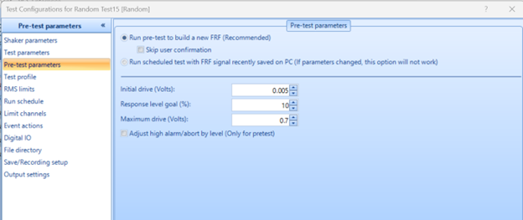
Before testing begins it is important to run a check to build a new FRF, or use previous FRF, based on a low input drive. The test will also check to make sure that the test drive will not exceed shaker parameters. Pretest drive and response level of ultimate testing excitation are adjustable to user preference.

Test Profile
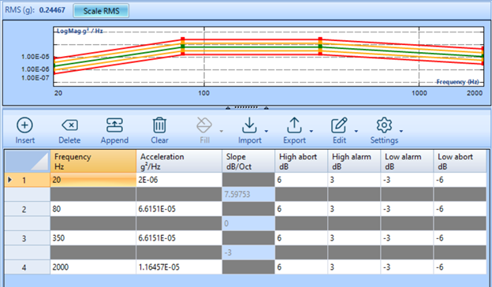
Test profiles for random tests will only display a broadband signal covering the defined frequency range. Test profile can be set to vary across frequency spectrum by magnitude and abort criterion. Acceleration output magnitude is adjustable by Scale RMS option above the control profile display.
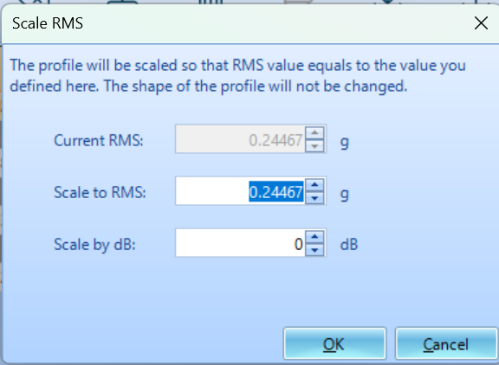RMS Scale
Output magnitude can be adjusted by dB or acceleration units.
RMS limits
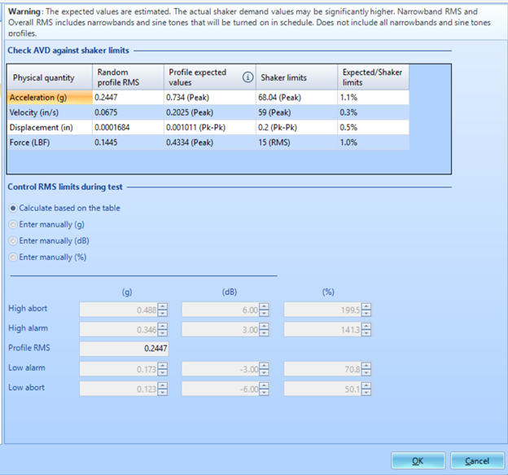
This page displays calculated values based on the test profile and abort limits previously set. Values can be scaled by profile RMS, same as Scale RMS, or by manually adjusting values of alarm and abort.

Run Schedule
Run schedule allows the user to define the testing process and resulting actions after a test is completed. Run schedule creation follows basic logic structuring and gives users options for setting the drive level, recording times, amplifier usage, report generation, loop creation and user defined events.
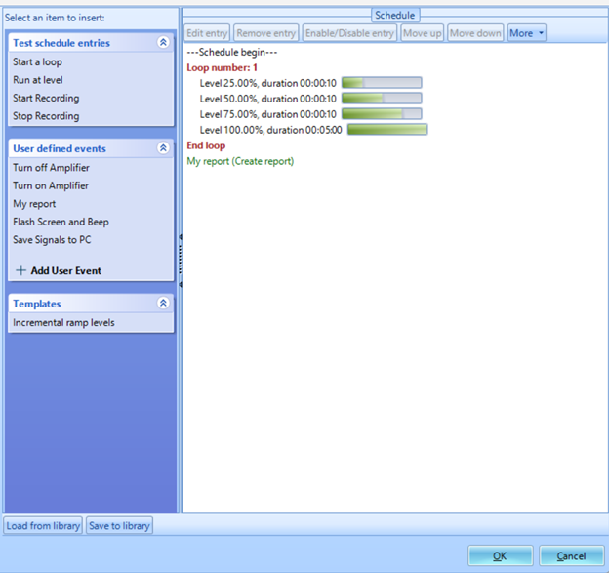
To create run schedule you simply click on the desired entry or event on the item to insert window. Once the item is clicked it will either be inserted into schedule or parameters pop up window will display and allow you to make adjustments. Once inserted into schedule it can be modified via the ribbon above the schedule. The placement of the entry can also be adjusted by dragging it into the correct placement.

Limit channels
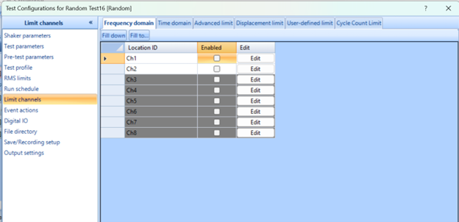
Limit channels allow for test controls to be placed at frequencies to adjust the abort test and alarm profiles. They are also responsible for notching procedures. Notching reduces the profile input around specified frequencies so that it can avoid resonance excitation which drives the response above abort limits.
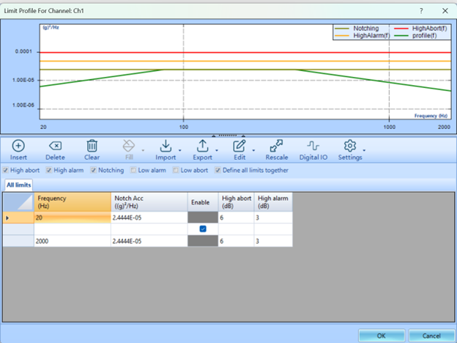

Event Actions
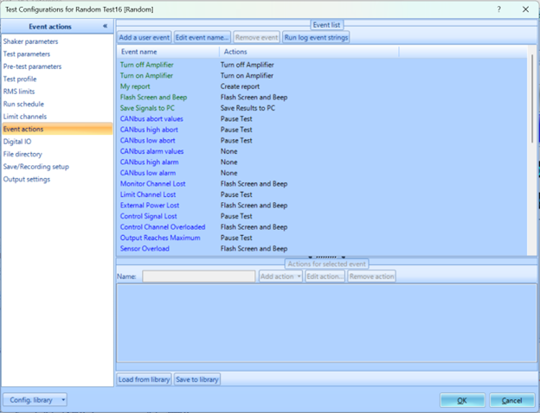
Event actions panel allows the user to define testing run schedule events. This can be used to run test procedures such as increase or decrease level, next entry, pause test and other similar actions. Events can also automate analysis process by generating reports, screen capture, and sending emails. User events are a powerful and diverse tool but are not required for testing purposes and are used only when needed for automation to meet testing requirements set by user.
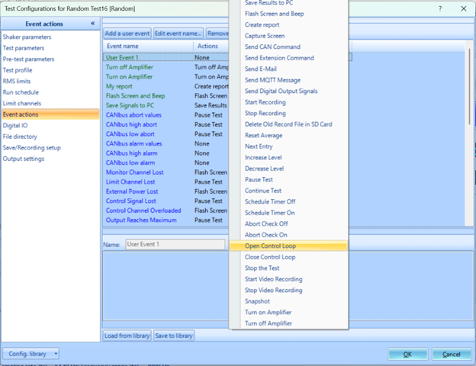

Digital IO
Digital Input/Output tab gives the user the options to send output signal before running and Digital Output when schedule ends or is aborted.

File Directory
Allows you to control where data is stored and naming conventions of files.

Save/Recording Setup
User can define when data should be saved to system.

Output Settings
Output settings give user control over which output channel should control shakers. Additionally, it can define second output channel and relation to primary drive.

