VCS UI Hardware Menu

Tools
Spider Configuration: Displays detected modules as well as currently selected spider’s information regarding model type serial number and EDM version.
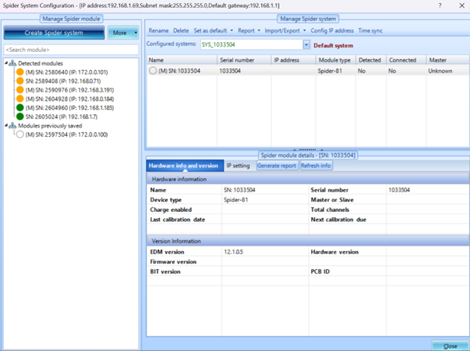
Spider Date & Time Settings: Set Date & Time to be synchronized with PC or to custom setup.
Global Settings: Allows customization of interface appearance, units, formatting, notifications and plot properties.
Working Folder: Sets the file browser/PC location of recording and saves data, as well as generated reports.
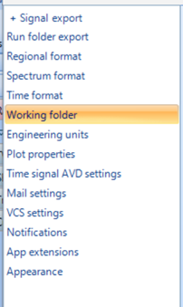

Report
Generates report of selected results or parameters, a word document with the relevant information will open and save.
Reports can also be generated based through the run schedule

Inputs
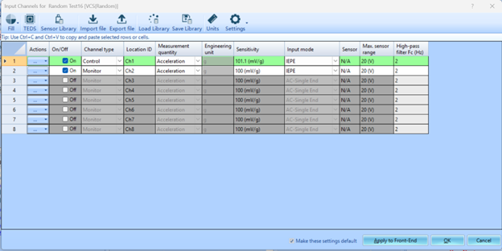
Input Channels for Test window allows you to define active channels as well as control and monitor channels. You can set the Name, Measurement, EU, Sensitivity and Input mode for the type of sensor used in test. High-pass and max range voltage range can also be set.

Settings
Shortcut to Global settings as described in Tools → Global settings.

