New Test Wizard
When starting the software or creating a new test type you will be presented with the following screen:
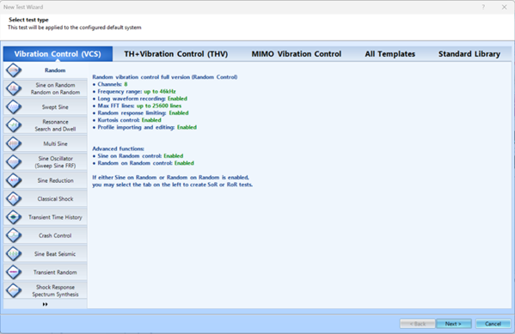

Ribbon
Vibration Control (VCS)
Standard single input single output closed loop control of a shaker
TH+Vibration Control (THV)
Allows for temperature, Humidity & Vibration control simultaneously
MIMO Vibration Control
Multiple Input Multiple Output and Multiple Excitors Single Axis (MESA) control types run through this panel
Allows for multiple control outputs to be used to control several degrees of freedom for UUT or greater force transfer to objects too large to be tested properly by a single shaker unit.
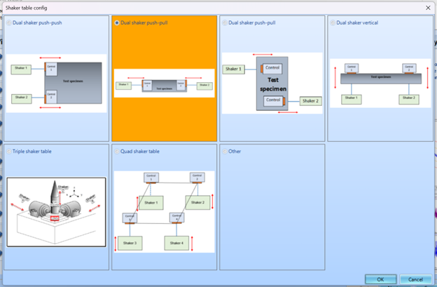
IF MIMO VC is selected, once test type is selected and you click next; you will be presented with the screen above to select the shaker setup you are working on.

Panels
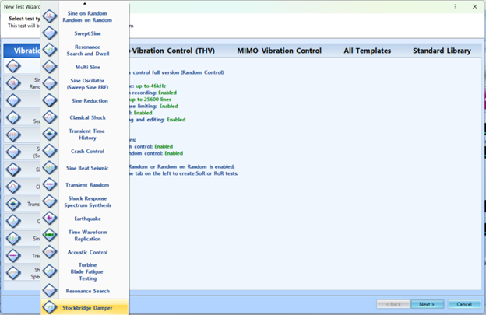
Test Types
The most used test types are Random, Sine Sweep & SRS
Random
Random excitation is often used to simulate real-world vibration. The purpose of the random vibration control system is to generate a true random drive signal such that, when the signal is applied via an amplifier/shaker to the device under test, the resulting shaker output spectrum will match the user-specified test profile. VCS also has the capability to perform Sine on Random (SoR) and Random on Random (RoR) testing.
Swept Sine
Unlike Random testing which generates many frequencies at once over the band of interest, Swept Sine testing generates energy at one frequency and sweeps this frequency through a preset range.
Classic Shock
A Shock test outputs a series of pulses to excite the structure under test. The response is measured at one or more locations on the structure and a spectral analysis is used to determine its response and resonance characteristics. This pulse response approximates the impulse response, the theoretical response to an infinitely tall and narrow spike function with an area of unity.
THV
Uses a limited set of tests available in VCS.
MIMO Vibration Control
Uses primarily the same testing types as VCS with custom features for MESA & MIMO applications. Additionally, it includes options for 3 Axis 6-DOF testing. Has a specialized Time waveform Replication with an iterative approach.

