VCS UI Signals Tab

Signals
Signals gives user control over settings related to display, appearance, data recording/saving and processing options.

PC Math Signals
Signals will display once entered Compute Signals using Math Functions tab and selecting Add
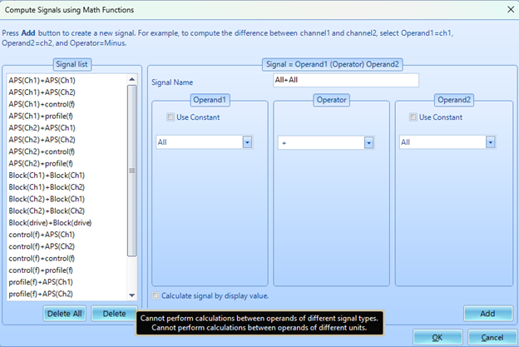
Operand 1 & 2 can be any time stream data input or a constant value of user selected choice. Operator options are limited to four basic functions: +, -, * and /.

PC FRF Signals
Similar to PC Math signals in selection style.
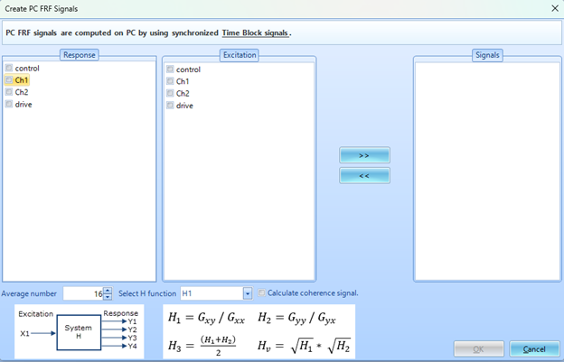
PC FRF signals give user options to create transfer functions for desired input (response) and output (excitation) channels. Also allows for customization of FRF and coherence calculations.

