EDM VCS UI Overview
For self-guided learning and troubleshooting the user guide within EDM applications is a great tool
User Guide

Topics
New Test Wizard
Includes physical testing type and setup information
Configuration
Includes testing configuration & control as well as trigger action and test reporting
Hardware
Includes Input channel & Spider System Setup
Display
Test drive and control profile as well as Time and Frequency domain results
Signals
Includes measurement and data collection setup and processing/filtering

Interface
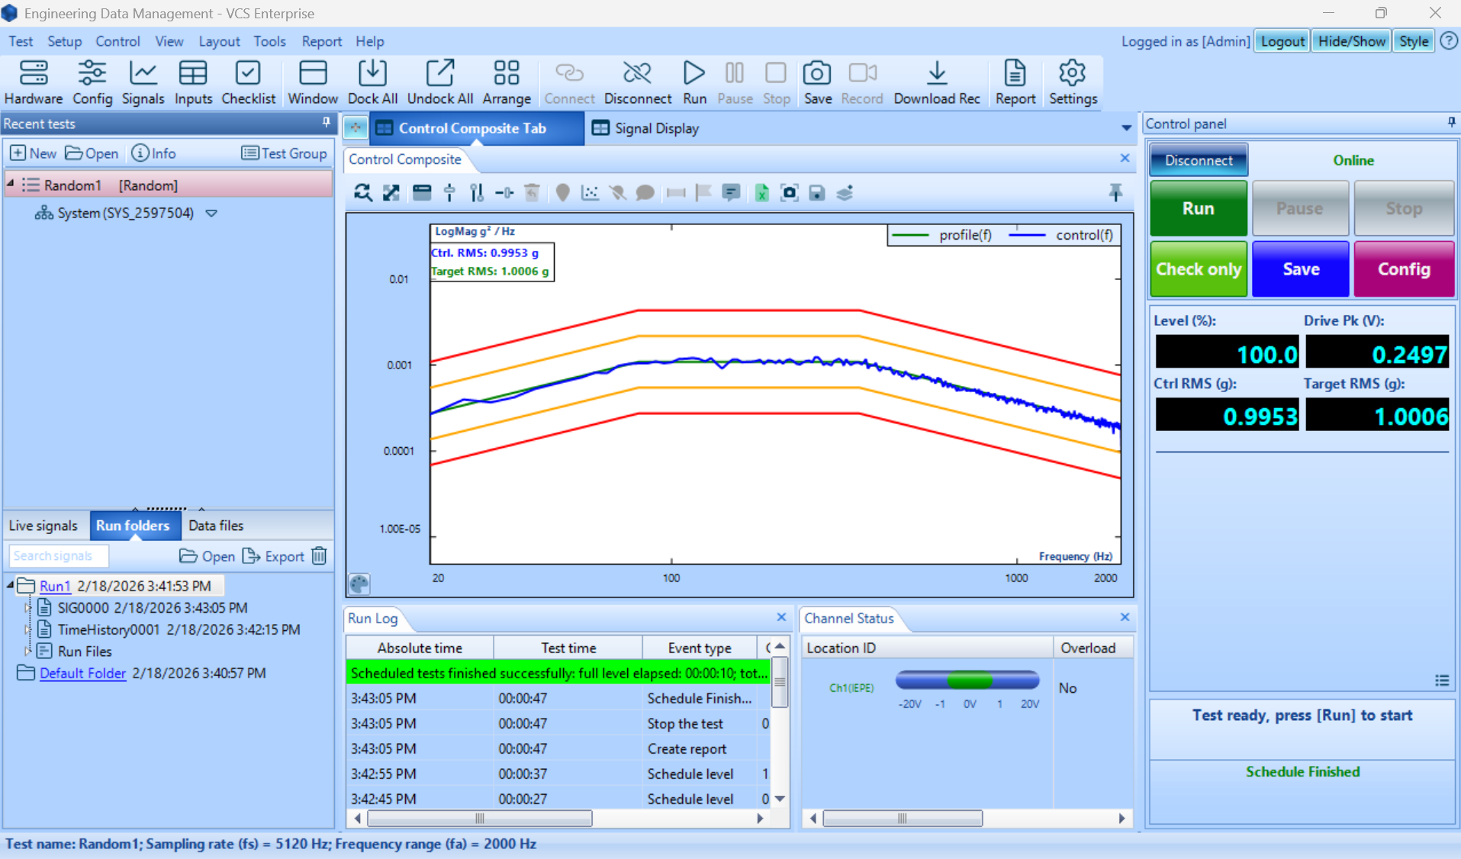

Ribbon

Test
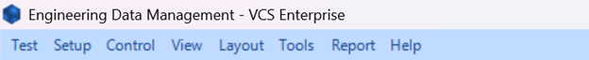
Similar to a “file” tab commonly found in other software. The test dropdown box gives options to create new tests, open previous tests, import test files, save and export tests.

Setup
Provides much of the same accessibility as the ribbon. Select Hardware Test Configurations Signals and Input channels will be discussed in the ribbon. The Test Sequence tab allows the user to customize testing options related to running multiple sequential tests. Black Box mode allows for multiple tests to be uploaded to the spider front-end so that they can be conducted when offline in the future. Additionally, EDM extensions are found in the Setup tab.

Control
Gives the user options related to conducting and saving the tests.

View
Gives users available display options. Creating and saving windows default displays and a few unique commands. Search resonance is useful for tests such as sine sweep and broadband random testing. Lissajous plots can be useful plotting two periodic signals against each other.

Layout
Organizational tools for displaying data, tiling the plots to the desired sections as well as providing functionality for exporting and importing tabs.

Tools
Tools menu gives access to hardware testing options and configurations as well as global settings menu and User notes.
Information is additionally covered in Hardware

Report
Generates report of selected results or parameters, a word document with the relevant information will open and save.
Reports can also be generated based through the run schedule

Help
Very useful tool for contacting support staff and providing necessary information.
CI Tech Support

Top Toolbar

Hardware
Displays available devices for connection & relevant connection settings
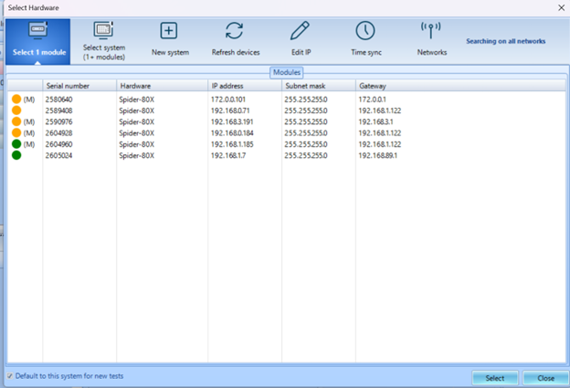

Config
Connects to testing configurations menu; the same destination as through the control panel and Setup → Test Configuration; Configuration

Signals
Further explained in testing signals setup Signals

Inputs
Inputs menu allows toggling of channels and configuration to meet sensor requirements
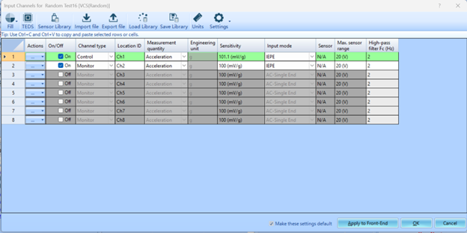

Checklist
Gives user overview of test setup and pre-check parameters. Checklist will automatically be displayed after clicking run as a final confirmation before test run schedule begins.

Report
Opens the Generate Report menu. Options include signal choice/selection, template, and run selection. Clicking Ok will automatically generate a report.

Settings
Opens to Global Settings, same as Tools → Global settings
Includes options for Engineering units, software appearance, plot properties, run folders and more.

Recent Test Tab & Signal Streams
Further discussion of Test & signal tabs within VCS UI Signals Tab
Recent Tests Terminal: Tests can be opened or created from this page and quickly accessed through recent test display. Test groups allow additional functionality for running sequential tests.
Signal Terminal: Contains all active signals within testing, including block and processed data.

Signal Display Window
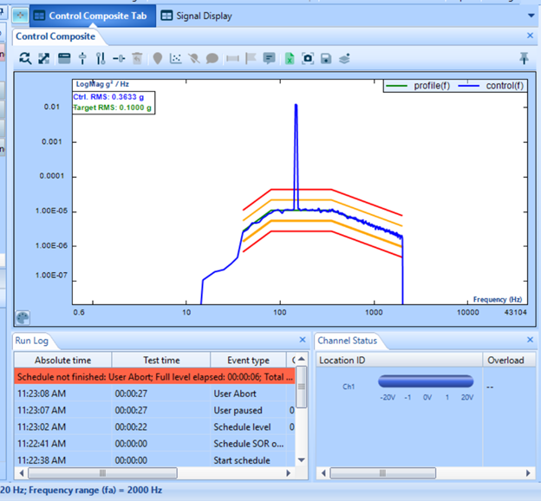SOR Profile
VCS UI Signals Display
The signal display window is useful for live control monitoring, data acquisition in real time, comparing data to industry standards, processing data to fit your testing requirements, report generation and more.

Control Panel
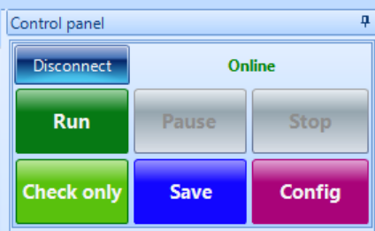
Gives user control over testing run. VCS UI Config

