Changing Engineering Units
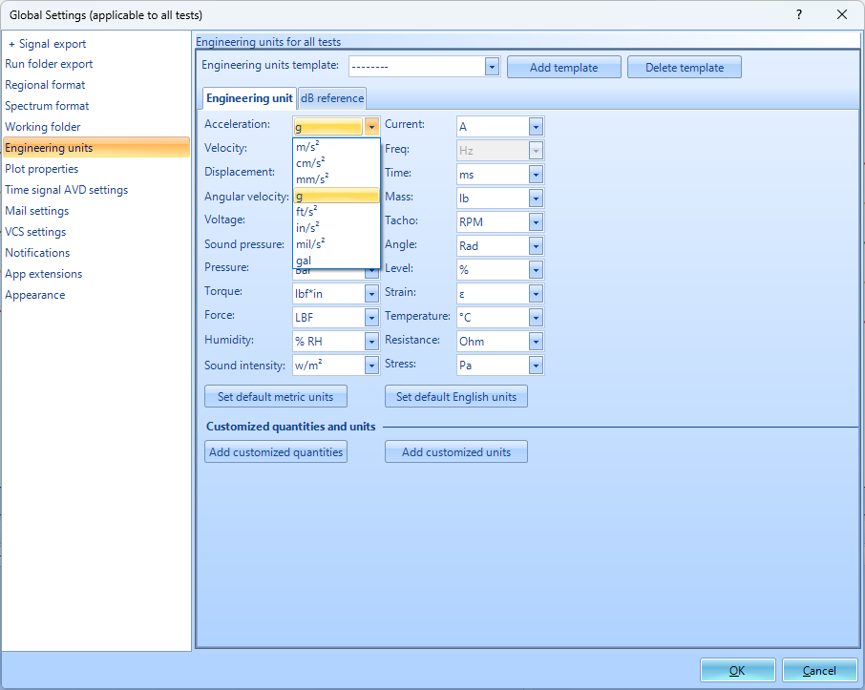
Here is how to change the displayed engineering units in EDM.
1. Go to Tools → Global Settings → Engineering Units or Setup → Engineering Units
2. You can select what measurement quantity you wish to change, and then select the new unit to use.
3. Data from previous measurements and recordings will automatically be converted to the new unit selected.

