VDS Diagnostics

Types of Diagnostics

Auto-diagnosis tools
- Machine builder
- Forcing Orders
- Machine Speed
- Baselines (Averages)
Auto diagnostic features come from the machine class. Machine class holds information such as machine elements (mechanical parts) forcing orders, speed/RPM and data collection points. Information on machine class contruction can be found here: VDS Machine Builder

Alarms
Alarms are a tool directly tied to a measurement entry, the rms and crest factor values are manually set for the entry
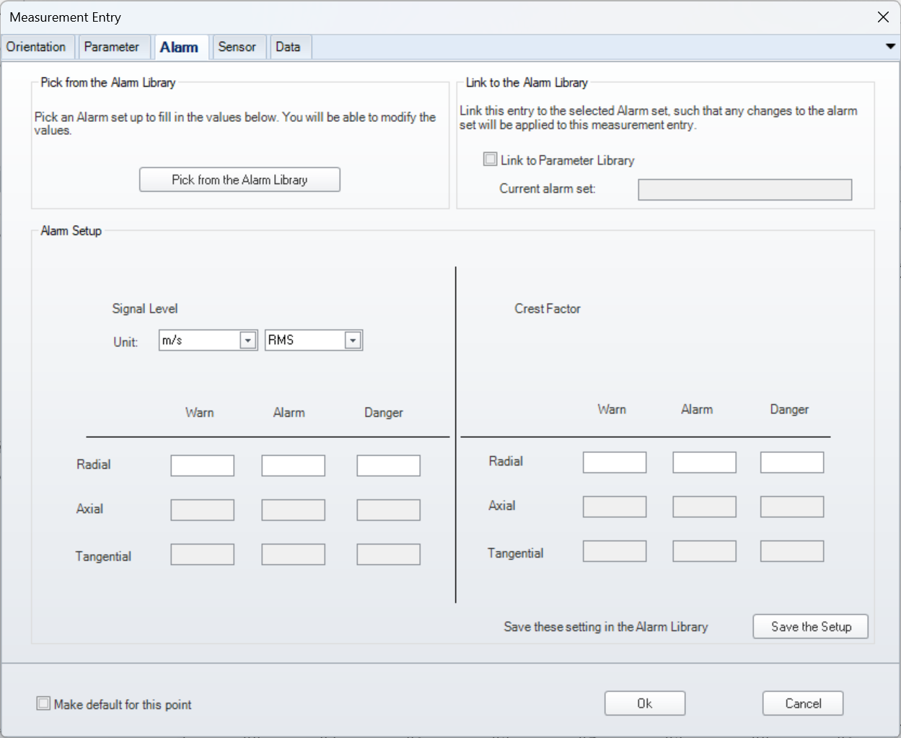

Fixed Thresholds & Baselines

Creation
Fixed thresholds and baselines are both created by selecting a point or machine class in the asset explorer and then navifating to the machine class page in the data explorer. Then right click on the pickup point you would like to create the baseline for and select average for a baseline or fixed threshold for a fixed threshold.
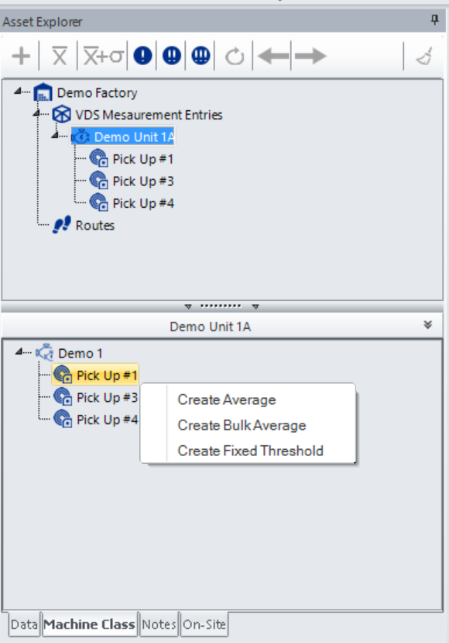
To create an average/baseline you will need to give the average a name order and # of points and then drag 3 healthy data collections from the point to use in the average.
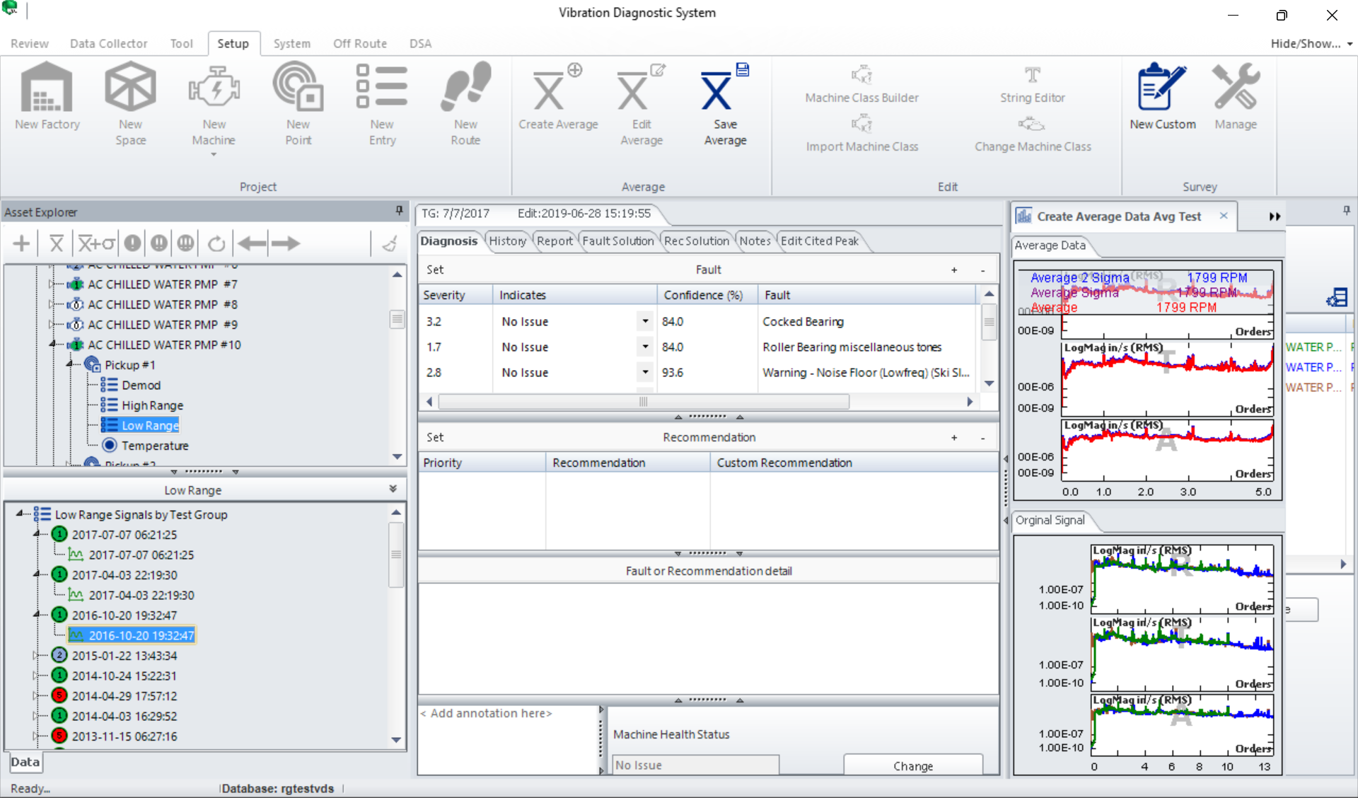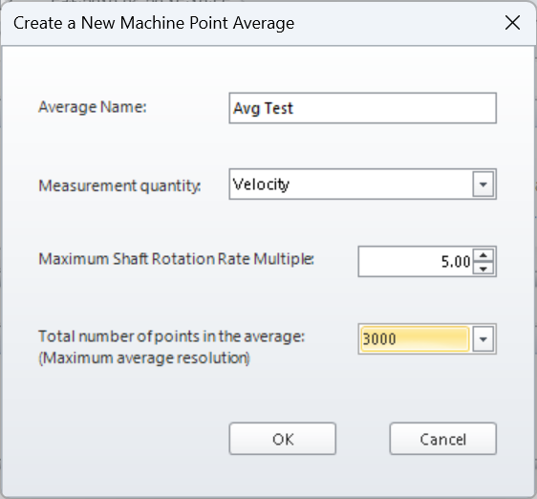
Thresholds will be created by selecting a severity level and then plotting points on a graph which will be overlaid onto the collected data
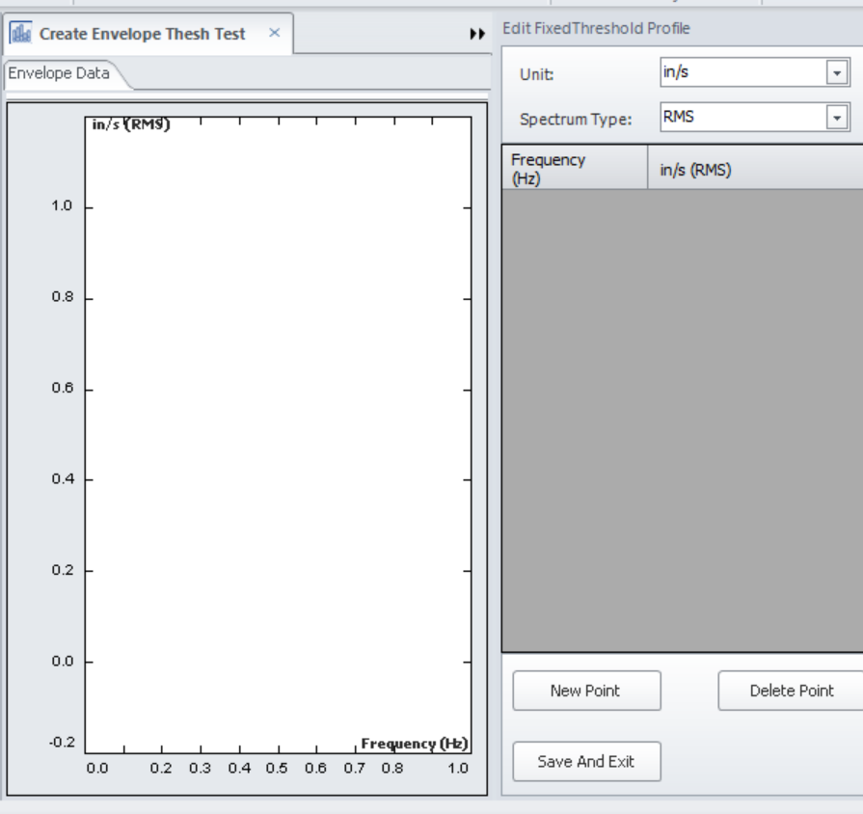
You can attach the threshold or baseline to a pickup point by right clicking the pickup point in the asset explorer.
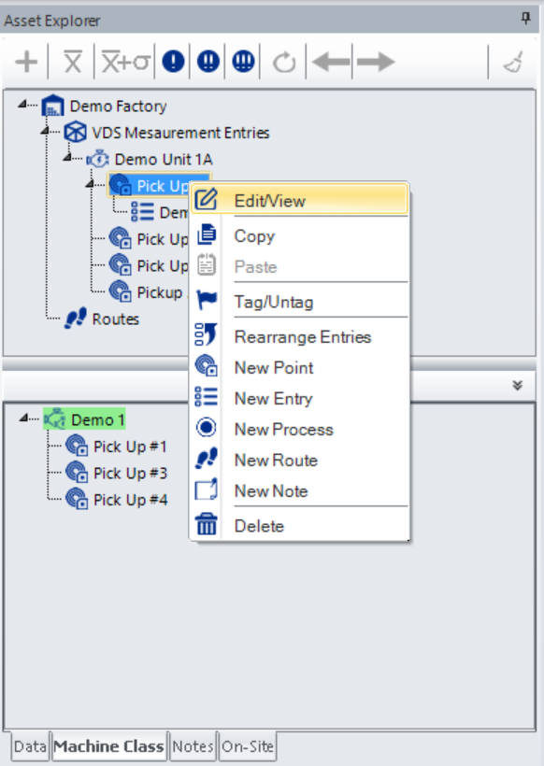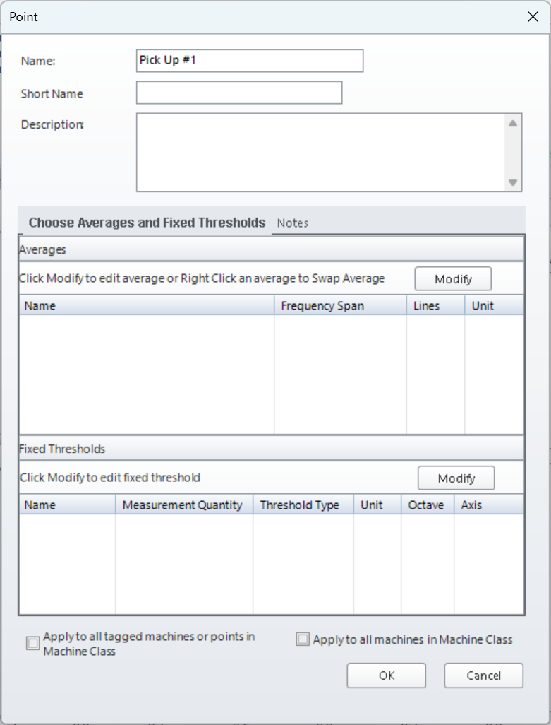
Once the baseline or threshold is attached it can be viewed by selecting the averages and threshold limits in the asset explorer toolbar
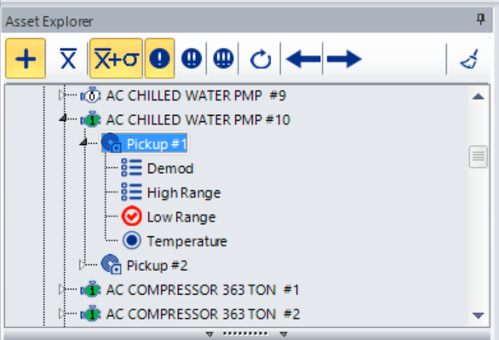

Diagnosis
Diagnostic information will be processed for the test group when route data is collected and uploaded to VDS if the option for auto-diagnostic processing is checked. Otherwise, the data can be processed by right clicking the data under the data explorer in selected point and clicking create diagnosis.

Report
Diagnostic information can be viewed in the review panel by selecting the View Diagnosis feature or by exporting the information from the tool page and selecting Diagnosis.
Information includes fault diagnosis, severity, confidence interval, and recommended action


