VDS Measurement Entries
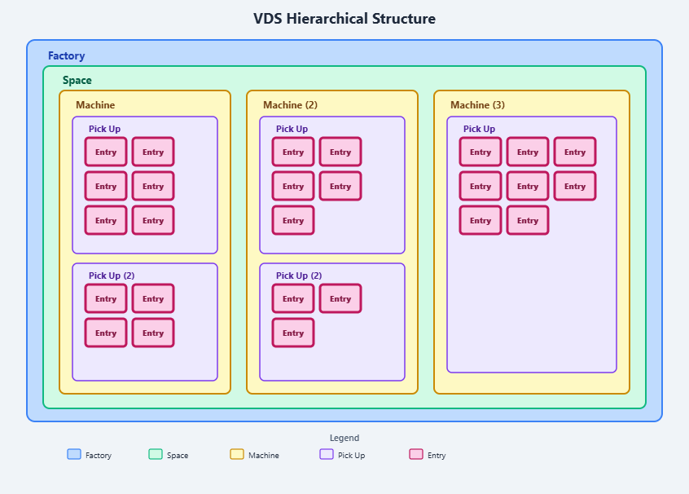
Entries are found under the pickup point in the hierarchical structure of the factory; they track to a specific measurement taken on the route

Entry Creation
New Entries can be created by going to the setup tab and finding New Entry on the Project Panel; in order to create an entry, you need to be selecting a Point or Entry in the asset explorer.
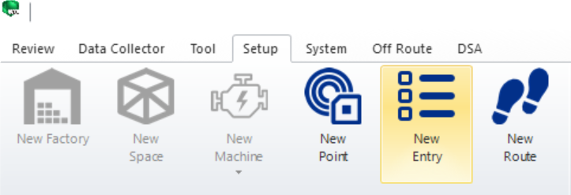

Orientation
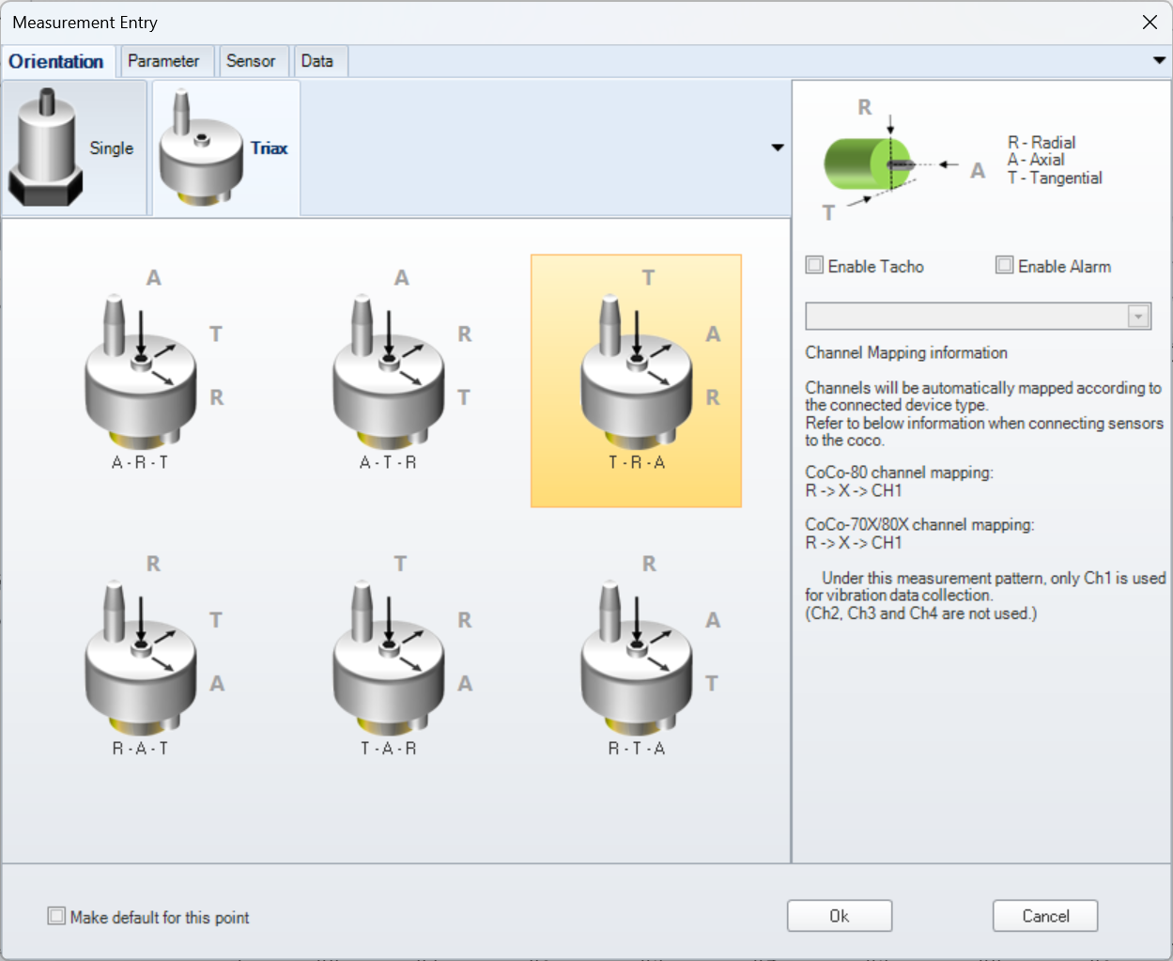
Entry creation starts with an orientation selection. Orientation options are available for single and triaxial sensors
Enable alarm & Enable Tacho options are found on the orientation screen as well. Enabling these options will make a new tab appear on the screen to input settings for selected feature.
To make this orientation default enable the “Make default for this point” option in the bottom left of the screen

Parameter
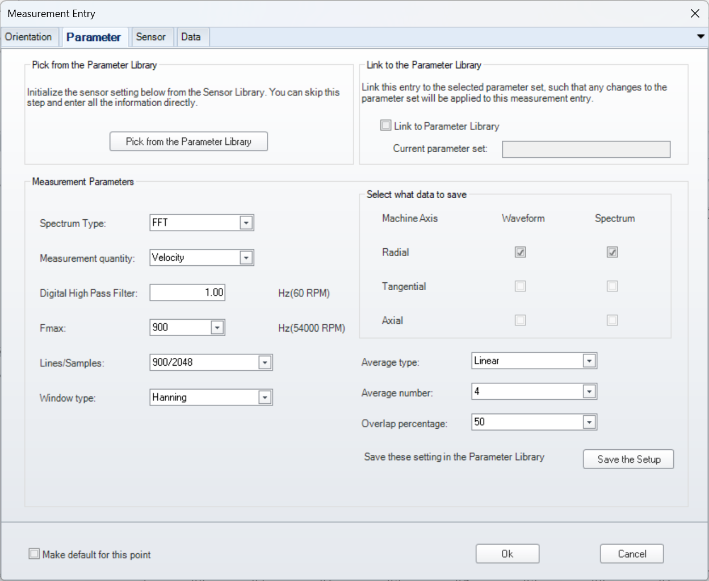
Parameter settings can be saved and selected from parameter library for quick entry creation.
Parameter settings include spectrum type measurement quantity filtering averaging and block settings. For auto-diagnostic features to function the measurement quantity must be set to Velocity This is not the sensor output measurement.

Alarm
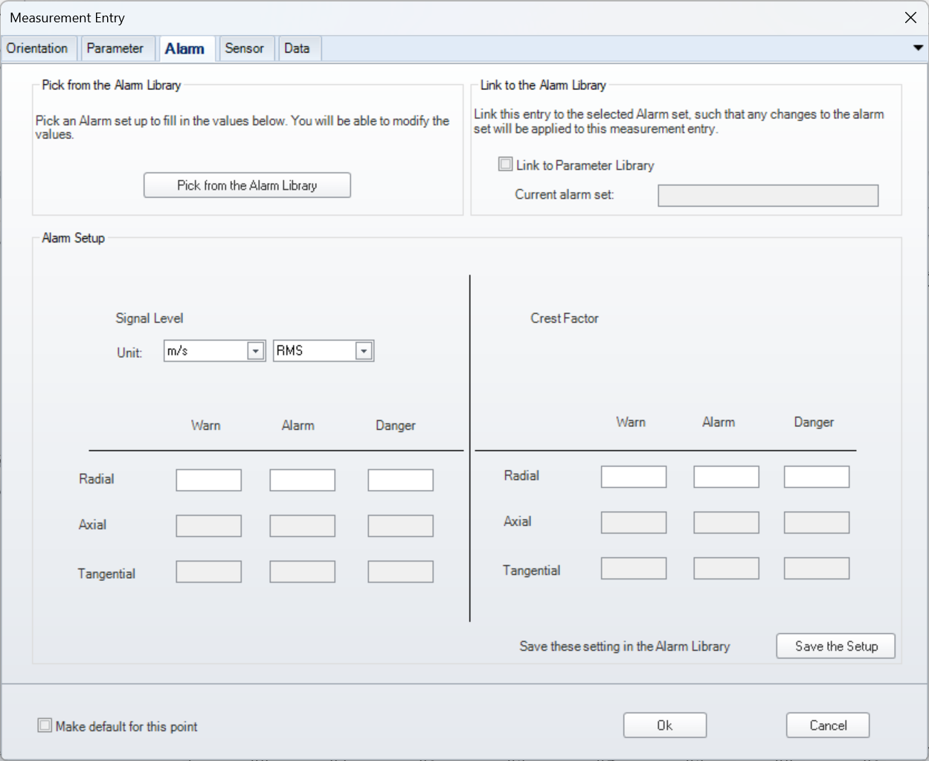
Alarm settings can be saved and loaded from library database. Alarm settings include the signal level units and measurement as well as the various intensities of the alarm.

Sensor
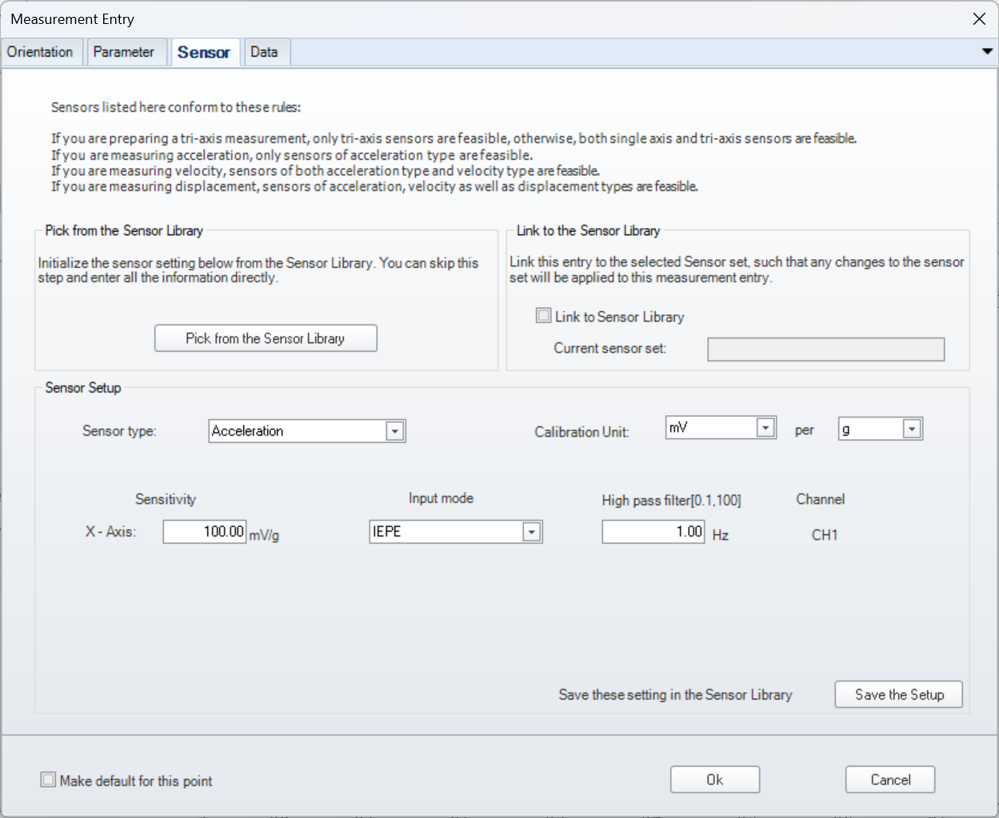
Sensors can be saved and loaded from the database library. This information will come from sensor manufacturer and includes sensitivity and input mode.

Data
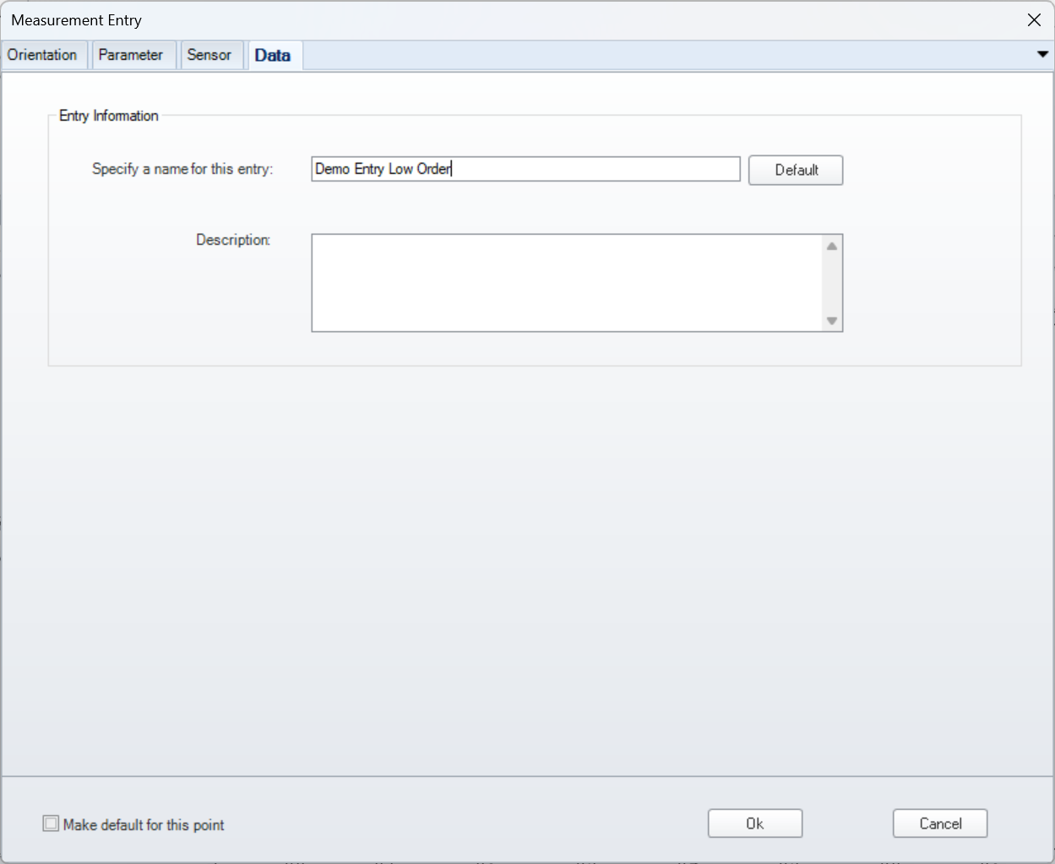
Give the entry a name and description

