VDS Machine Builder
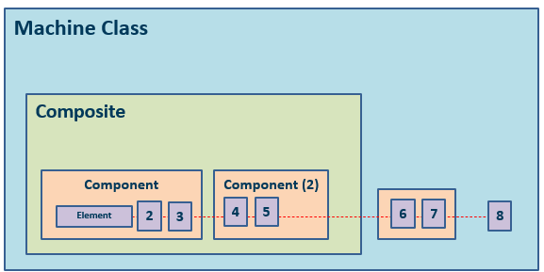

Machine Structure
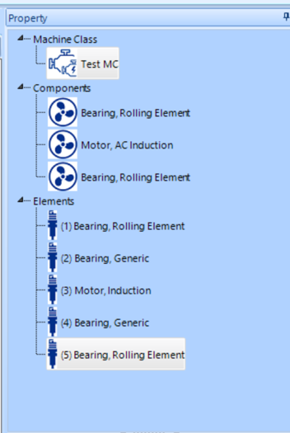
Machine Class: The machine class represents the full model of the machine. Includes RPM and speed variation information. Automated diagnostics are run at the machine class level
Composites: composites are composed of several components and are used for inter-component issues i.e. pulleys and gear compressors.
Components: collection of elements on a single shaft
Elements: a mechanical part i.e. bearings, fans, and motors

Machine Construction
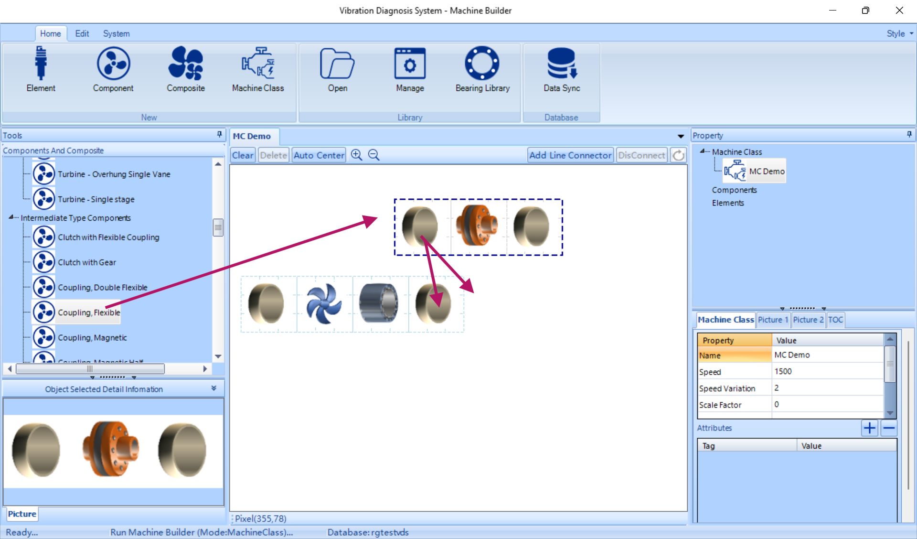
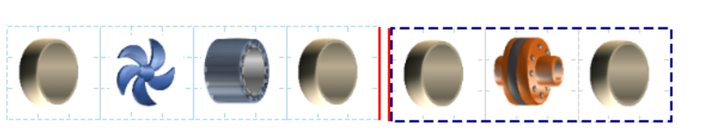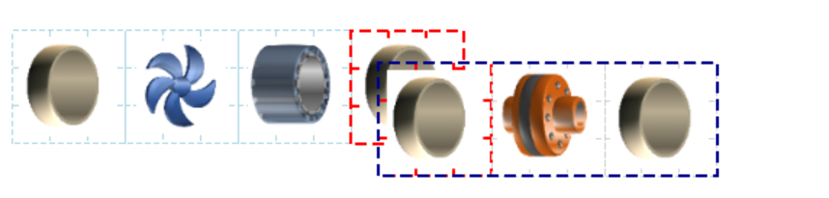
Component and element features can be edited by selecting either the component or sub element in the demo window or property selection. To select an element in the demo window 1st click on the part to select the component then click again to enter element selection.
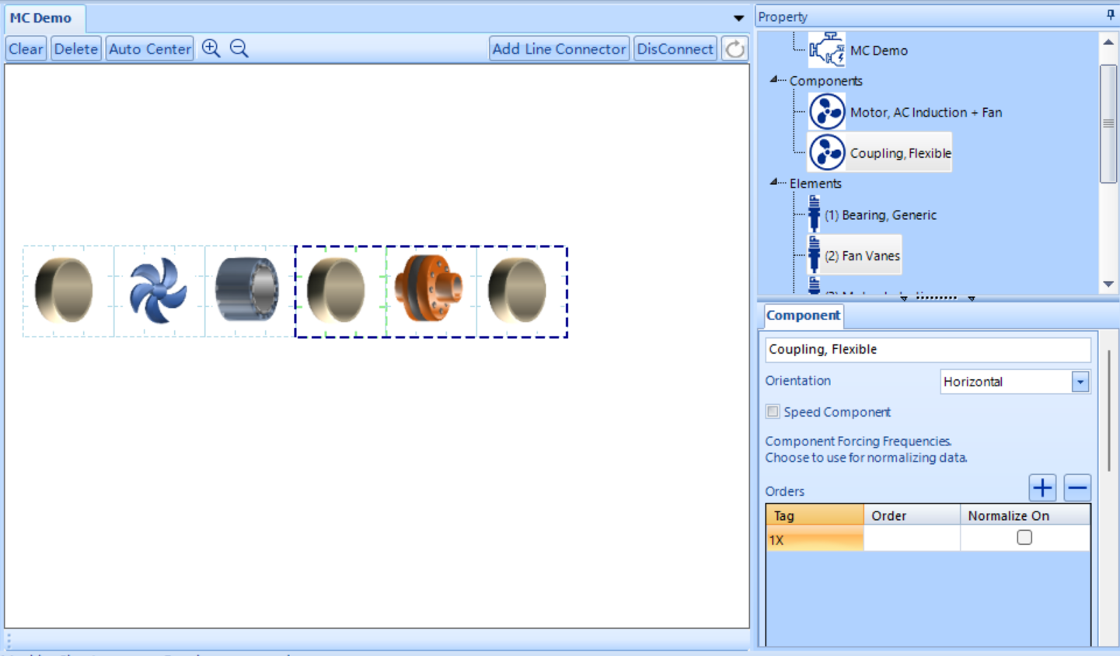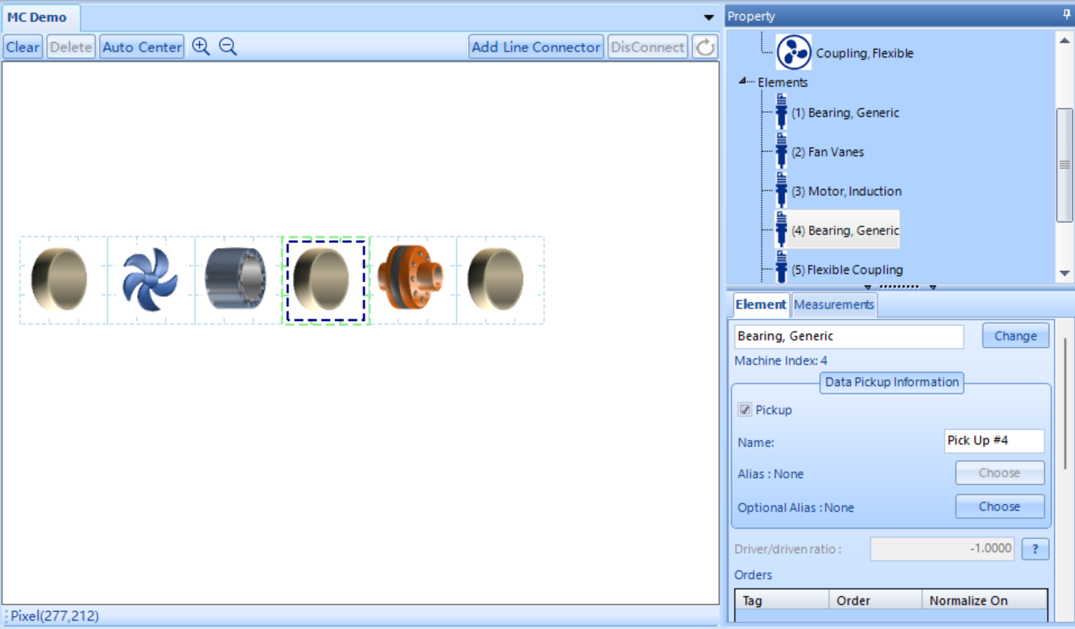
Component settings allows you to set the speed component.
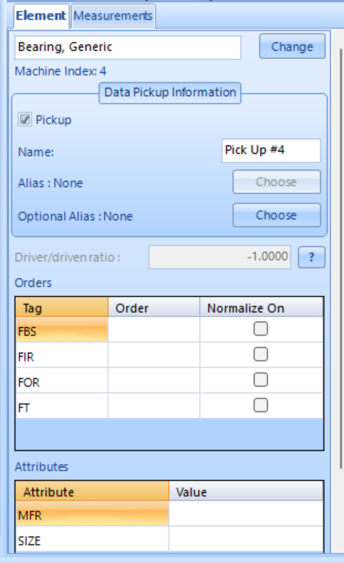
Element settings allows for you to select if the element is a pickup point and adjust diagnostic features as well as input information such as forcing orders and pole count.

