VDS Pickups

Pick Up
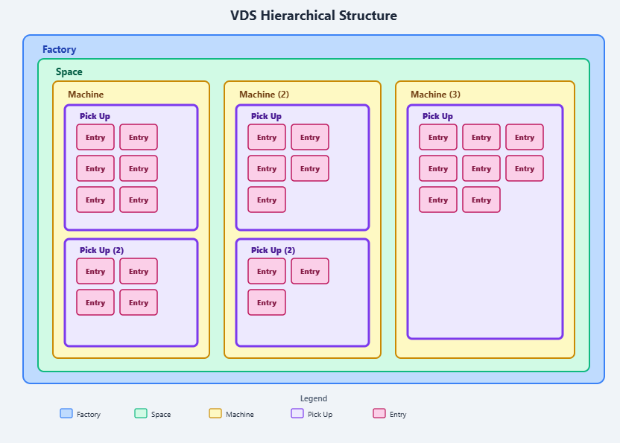
Pick Ups are found under the machine class in the hierarchical structure of a Factory
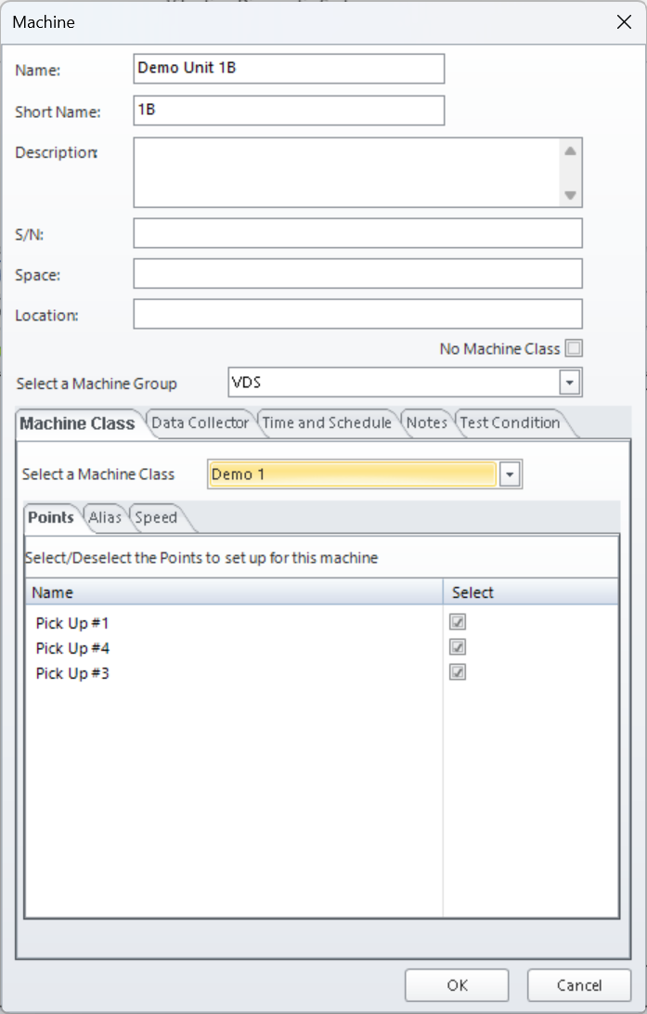
Defined by a physical data collection location on a machine in your factory
Can be directly tied to an element in a machine class through the machine builder
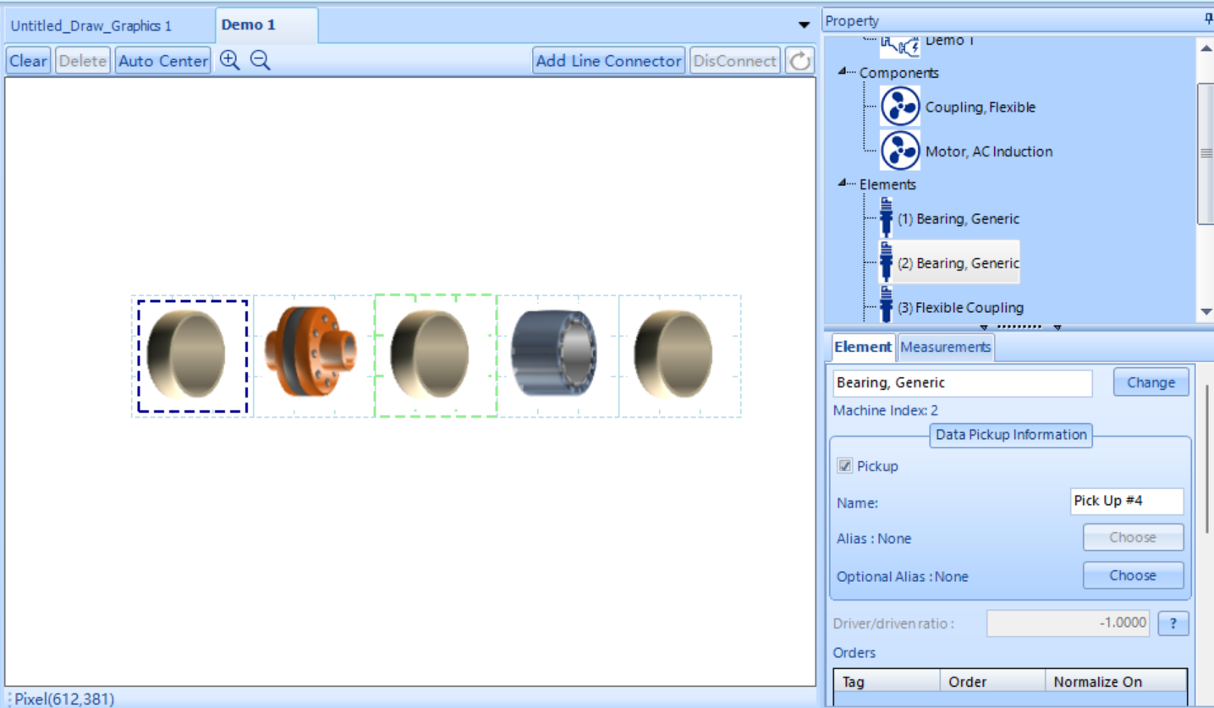
Diagnostic information such as fixed thresholds and baselines are tied to pick up points.
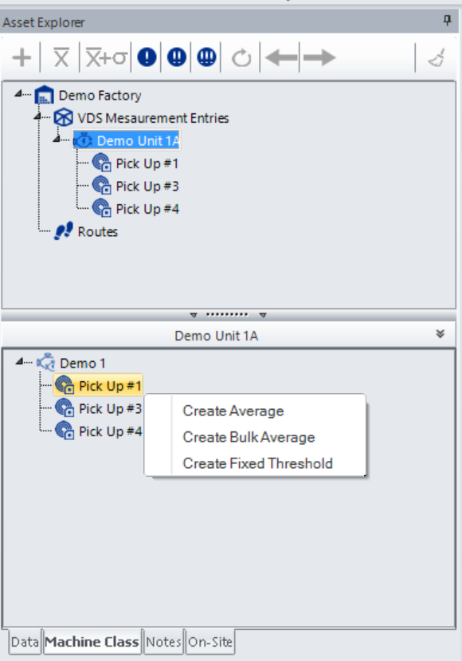
Baselines and Fixed Thresholds are created through the data explorer by selecting the pick up point or parent machine in the asset explorer, tabbing over to Machine Class and then right clicking the pick up to build the data analysis feature.

